UNITED STATES
SECURITIES AND EXCHANGE COMMISSION
WASHINGTON, D.C. 20549

FORM 8-K

CURRENT REPORT
Pursuant to Section 13 or 15(d) of the Securities Exchange Act of 1934
Date of Report (Date of earliest event reported): May 13, 2026

AVISTA CORPORATION
(Exact name of Registrant as Specified in Its Charter)

Washington |  |  | 001-03701 | 91-0462470
(State or Other Jurisdiction  of Incorporation) |  |  | (Commission File Number) | (IRS Employer  Identification No.)
1411 East Mission Avenue
Spokane, Washington |  |  |  | 99202-2600
(Address of Principal Executive Offices) |  |  |  | (Zip Code)

Registrant’s Telephone Number, Including Area Code: 509 489-0500

(Former Name or Former Address, if Changed Since Last Report)

Check the appropriate box below if the Form 8-K filing is intended to simultaneously satisfy the filing obligation of the registrant under any of the following provisions:
☐Written communications pursuant to Rule 425 under the Securities Act (17 CFR 230.425)
☐Soliciting material pursuant to Rule 14a-12 under the Exchange Act (17 CFR 240.14a-12)
☐Pre-commencement communications pursuant to Rule 14d-2(b) under the Exchange Act (17 CFR 240.14d-2(b))
☐Pre-commencement communications pursuant to Rule 13e-4(c) under the Exchange Act (17 CFR 240.13e-4(c))
Securities registered pursuant to Section 12(b) of the Act:
Title of each class |  | Trading  Symbol(s) |  | Name of each exchange on which registered
Common Stock |  | AVA |  | The New York Stock Exchange
Indicate by check mark whether the registrant is an emerging growth company as defined in Rule 405 of the Securities Act of 1933 (§ 230.405 of this chapter) or Rule 12b-2 of the Securities Exchange Act of 1934 (§ 240.12b-2 of this chapter).
Emerging growth company ☐
If an emerging growth company, indicate by check mark if the registrant has elected not to use the extended transition period for complying with any new or revised financial accounting standards provided pursuant to Section 13(a) of the Exchange Act. ☐

Section 7 – Regulation FD

Item 7.01 Regulation FD Disclosure.
On May 13, 2026, Avista Corporation (Avista Corp.) made available an investor presentation, which is accessible at the Company's website at https://investor.avistacorp.com. A copy of this presentation is furnished as Exhibit 99.1 to this report.

Section 9 – Financial Statements and Exhibits

Item 9.01 Financial Statements and Exhibits.
(d) | Exhibits
99.1 | May 2026 investor presentation which is being furnished pursuant to Item 7.01
104 | Cover Page Interactive Data File (formatted as inline XBRL with applicable taxonomy extension information contained in Exhibits 101.)

The information contained in Item 7.01, as well as Exhibit 99.1, is “furnished” pursuant to General Instruction B2 to Form 8-K, shall not be considered “filed” for purposes of Section 18 of the Securities Exchange Act of 1934 (“Exchange Act”) and shall not be incorporated by reference into any filing under the Securities Act of 1933 (“Securities Act”) or the Exchange Act. Accordingly, such information shall not be subject to the liabilities of Section 18 of the Exchange Act or Section 11 or 12(a)(2) of the Securities Act.
Neither the references to Avista Corp.’s internet website in this Current Report nor the posting of any financial presentation on such website shall, under any circumstances, be deemed to incorporate any information available on such website into this Current Report. The information available on Avista Corp.’s internet website is not part of this Current Report or any other report or other document furnished or filed by Avista Corp. with the Securities and Exchange Commission.

SIGNATURES
Pursuant to the requirements of the Securities Exchange Act of 1934, the registrant has duly caused this report to be signed on its behalf by the undersigned thereunto duly authorized.
 |  | AVISTA CORPORATION
 |  | (Registrant)
Date: | May 13, 2026 | /s/ Kevin J. Christie
Senior Vice President, Chief Financial Officer,
Treasurer and Regulatory Affairs Officer

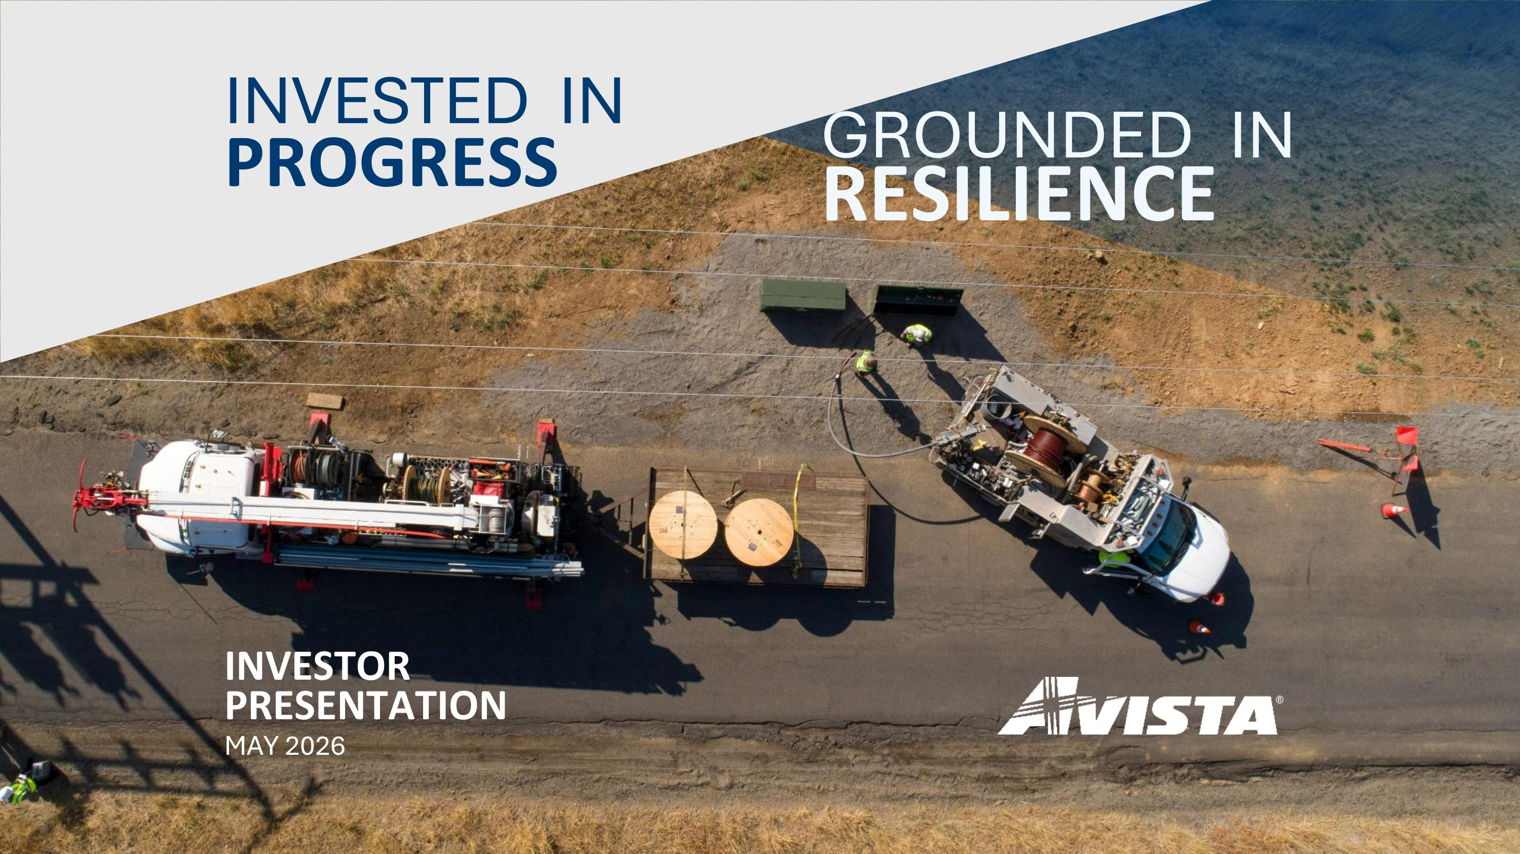
INVESTED IN PROGRESS GROUNDED IN RESILIENCE INVESTOR PRESENTATION MAY 2026

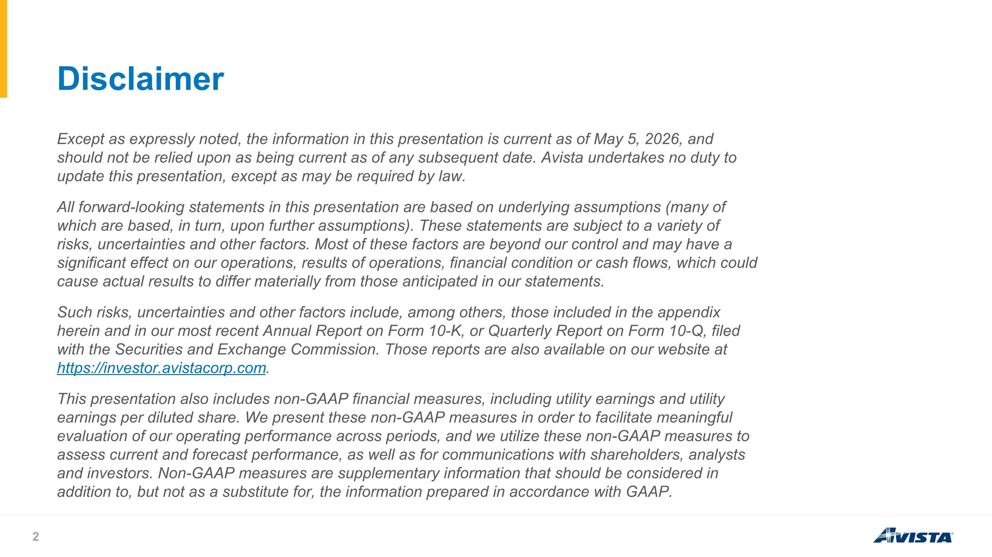
Disclaimer Except as expressly noted, the information in this presentation is current as of May 5, 2026, and should not be relied upon as being current as of any subsequent date. Avista undertakes no duty to update this presentation, except as may be required by law. All forward-looking statements in this presentation are based on underlying assumptions (many of which are based, in turn, upon further assumptions). These statements are subject to a variety of risks, uncertainties and other factors. Most of these factors are beyond our control and may have a significant effect on our operations, results of operations, financial condition or cash flows, which could cause actual results to differ materially from those anticipated in our statements. Such risks, uncertainties and other factors include, among others, those included in the appendix herein and in our most recent Annual Report on Form 10-K, or Quarterly Report on Form 10-Q, filed with the Securities and Exchange Commission. Those reports are also available on our website at https://investor.avistacorp.com. This presentation also includes non-GAAP financial measures, including utility earnings and utility earnings per diluted share. We present these non-GAAP measures in order to facilitate meaningful evaluation of our operating performance across periods, and we utilize these non-GAAP measures to assess current and forecast performance, as well as for communications with shareholders, analysts and investors. Non-GAAP measures are supplementary information that should be considered in addition to, but not as a substitute for, the information prepared in accordance with GAAP.

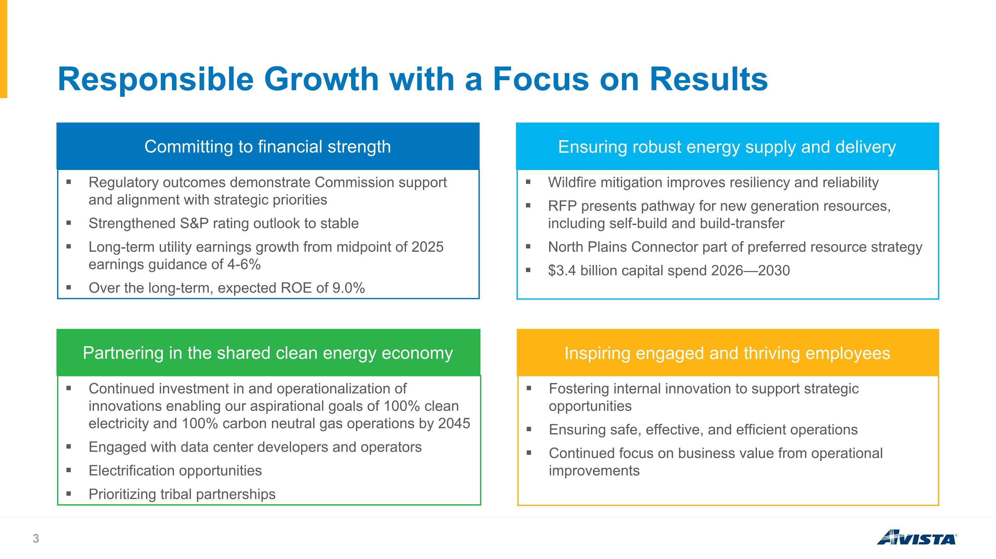
Responsible Growth with a Focus on Results Committing to financial strength Ensuring robust energy supply and delivery Regulatory outcomes demonstrate Commission support and alignment with strategic priorities Strengthened S&P rating outlook to stable Long-term utility earnings growth from midpoint of 2025 earnings guidance of 4-6% Over the long-term, expected ROE of 9.0% Wildfire mitigation improves resiliency and reliability RFP presents pathway for new generation resources, including self-build and build-transfer North Plains Connector part of preferred resource strategy $3.4 billion capital spend 2026—2030 Partnering in the shared clean energy economy Inspiring engaged and thriving employees Continued investment in and operationalization of innovations enabling our aspirational goals of 100% clean electricity and 100% carbon neutral gas operations by 2045 Engaged with data center developers and operators Electrification opportunities Prioritizing tribal partnerships Fostering internal innovation to support strategic opportunities Ensuring safe, effective, and efficient operations Continued focus on business value from operational improvements

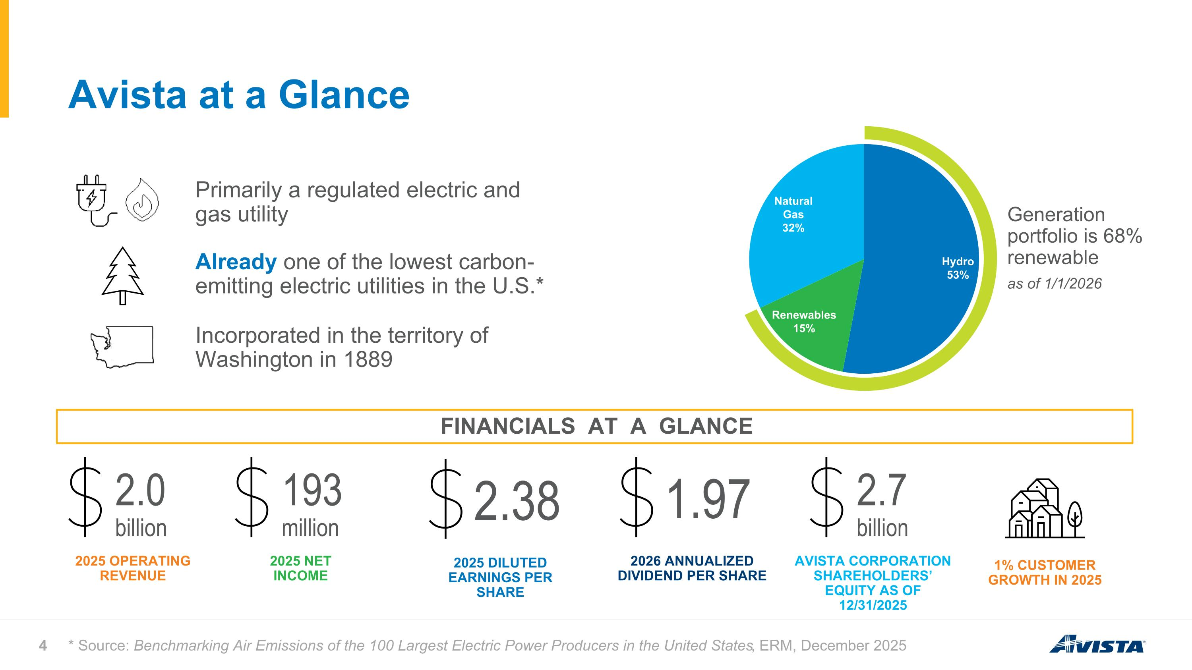
Avista at a Glance Primarily a regulated electric and gas utility Incorporated in the territory of Washington in 1889 FINANCIALS AT A GLANCE 2.0 billion 2025 OPERATING REVENUE 193 million 2025 NET INCOME 2.38 2025 DILUTED EARNINGS PER SHARE 1.97 2026 ANNUALIZED DIVIDEND PER SHARE 2.7 billion AVISTA CORPORATION SHAREHOLDERS’ EQUITY AS OF 12/31/2025 1% CUSTOMER GROWTH IN 2025 Already one of the lowest carbon-emitting electric utilities in the U.S.* * Source: Benchmarking Air Emissions of the 100 Largest Electric Power Producers in the United States, ERM, December 2025 Generation portfolio is 68% renewable as of 1/1/2026

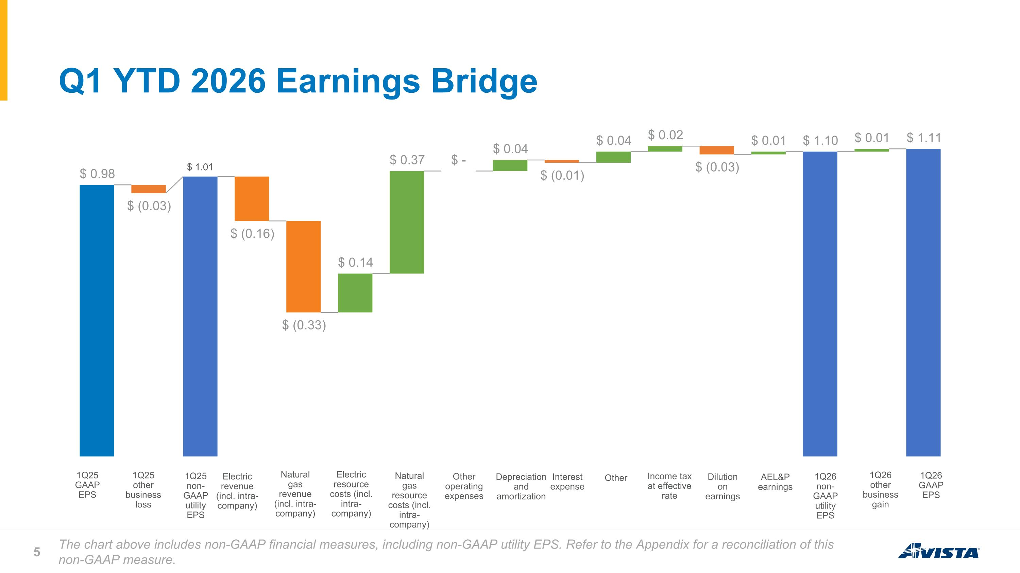
Q1 YTD 2026 Earnings Bridge 1Q25 GAAP EPS 1Q25 other business loss 1Q25 non-GAAP utility EPS Electric revenue (incl. intra-company) Natural gas revenue (incl. intra-company) Other operating expenses Depreciation and amortization Interest expense Other Income tax at effective rate Dilution on earnings AEL&P earnings 1Q26 non-GAAP utility EPS 1Q26 other business gain 1Q26 GAAP EPS The chart above includes non-GAAP financial measures, including non-GAAP utility EPS. Refer to the Appendix for a reconciliation of this non-GAAP measure. Electric resource costs (incl. intra-company) Natural gas resource costs (incl. intra-company)

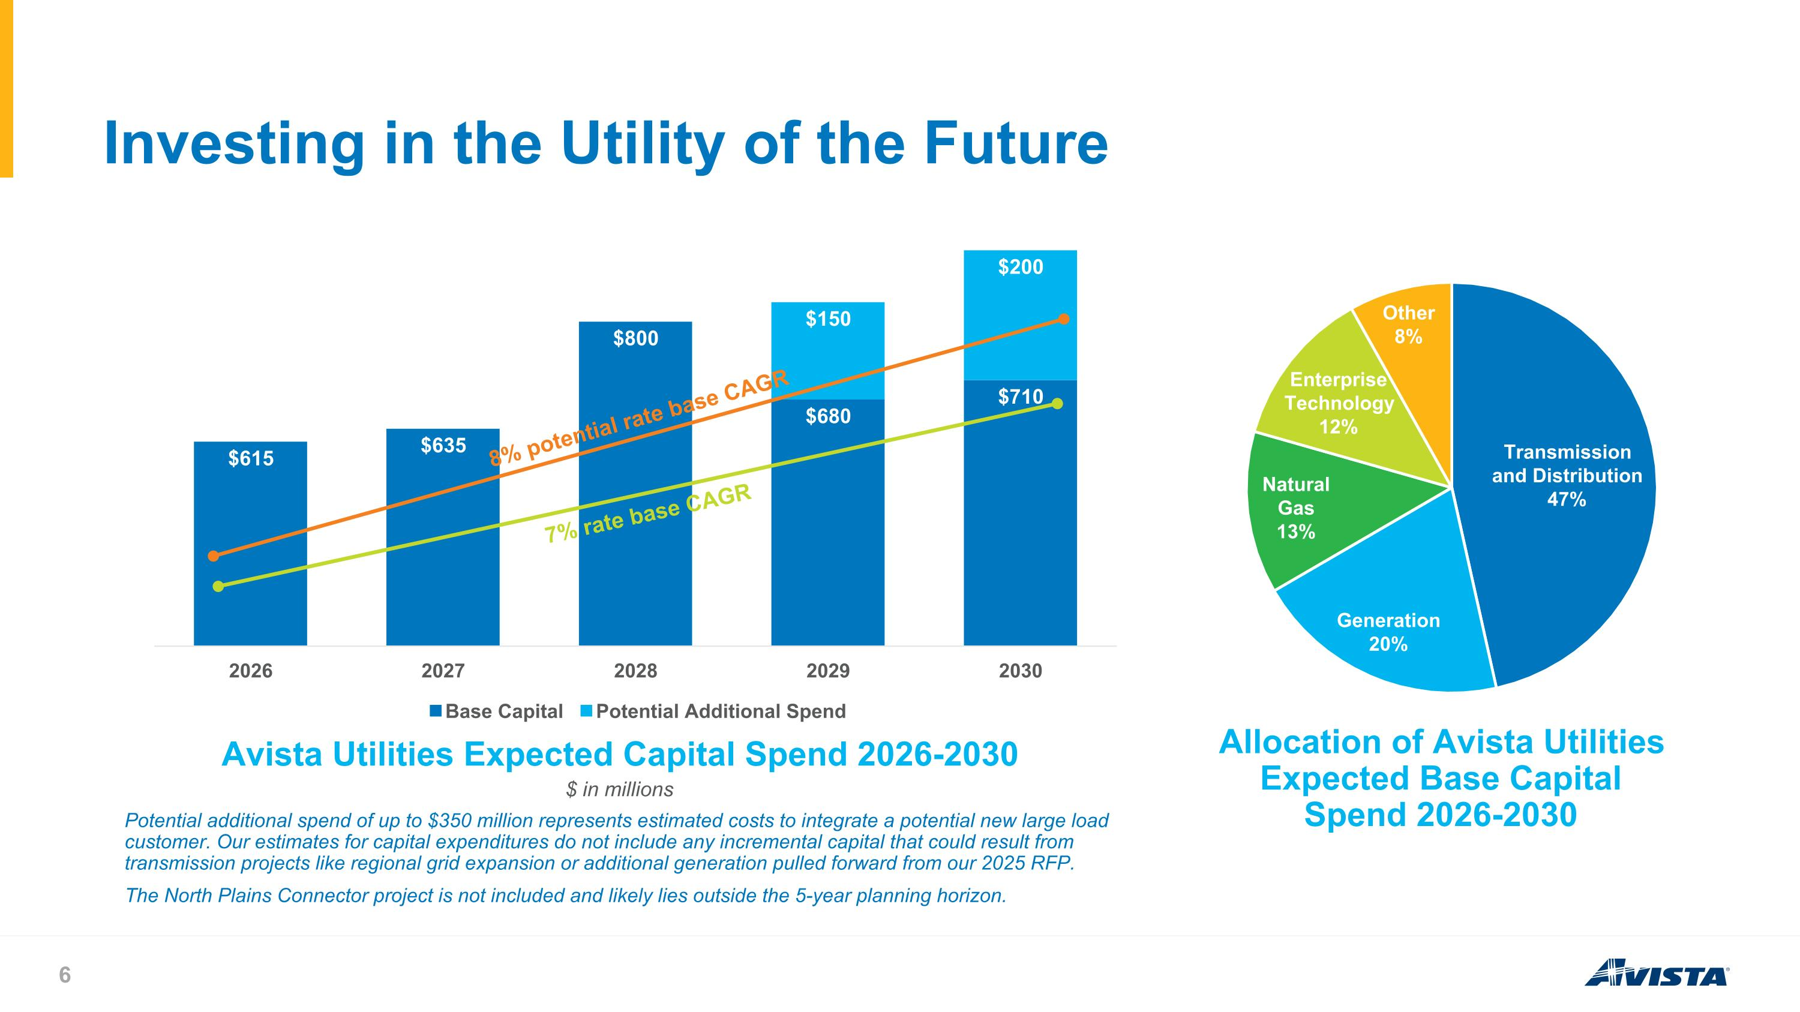
Investing in the Utility of the Future Avista Utilities Expected Capital Spend 2026-2030 Allocation of Avista Utilities Expected Base Capital Spend 2026-2030 $ in millions Potential additional spend of up to $350 million represents estimated costs to integrate a potential new large load customer. Our estimates for capital expenditures do not include any incremental capital that could result from transmission projects like regional grid expansion or additional generation pulled forward from our 2025 RFP. The North Plains Connector project is not included and likely lies outside the 5-year planning horizon. 7% rate base CAGR 8% potential rate base CAGR

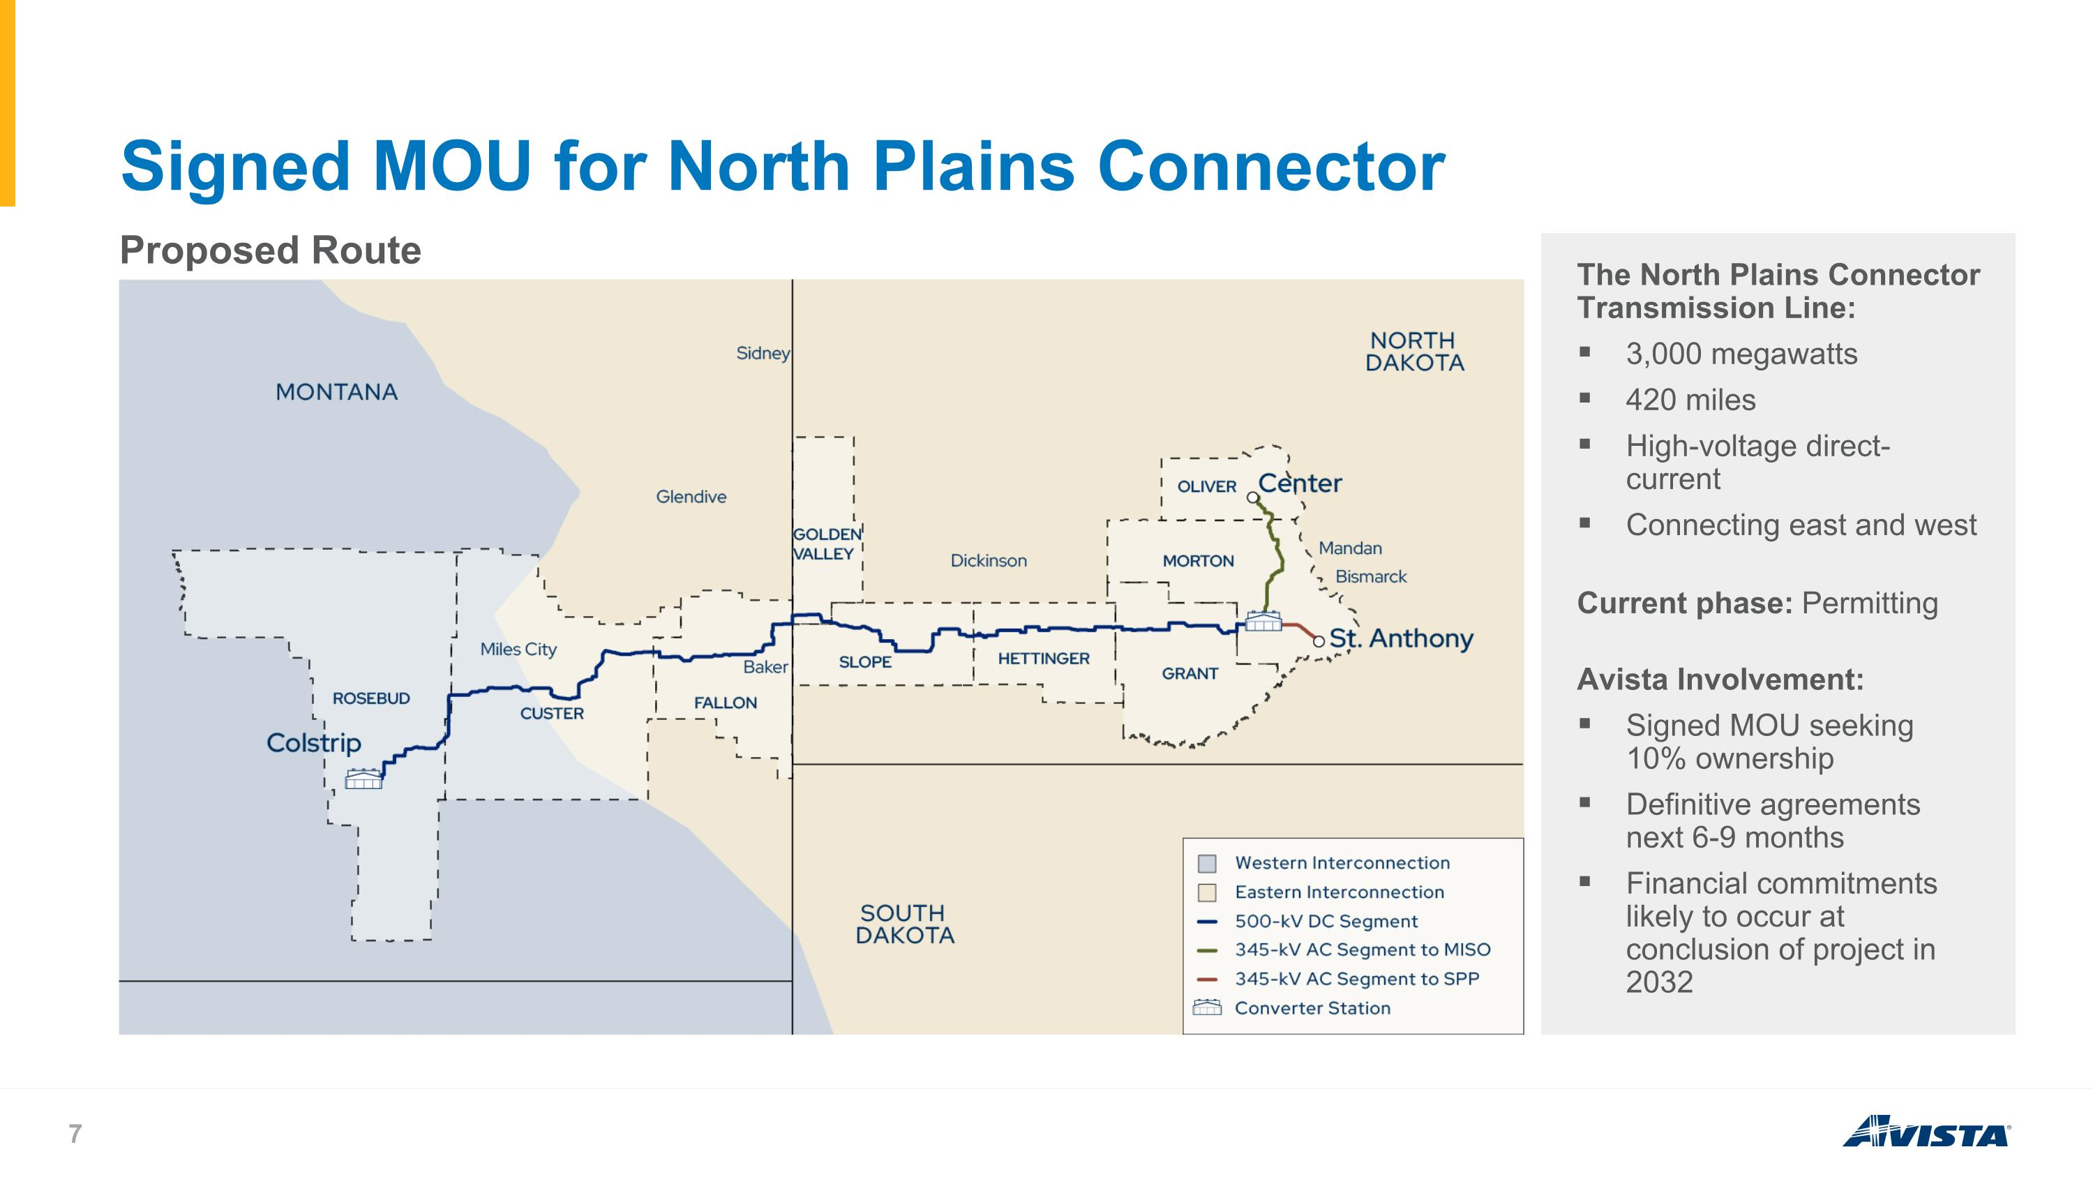
Signed MOU for North Plains Connector Proposed Route The North Plains Connector Transmission Line: 3,000 megawatts 420 miles High-voltage direct-current Connecting east and west Current phase: Permitting Avista Involvement: Signed MOU seeking 10% ownership Definitive agreements next 6-9 months Financial commitments likely to occur at conclusion of project in 2032

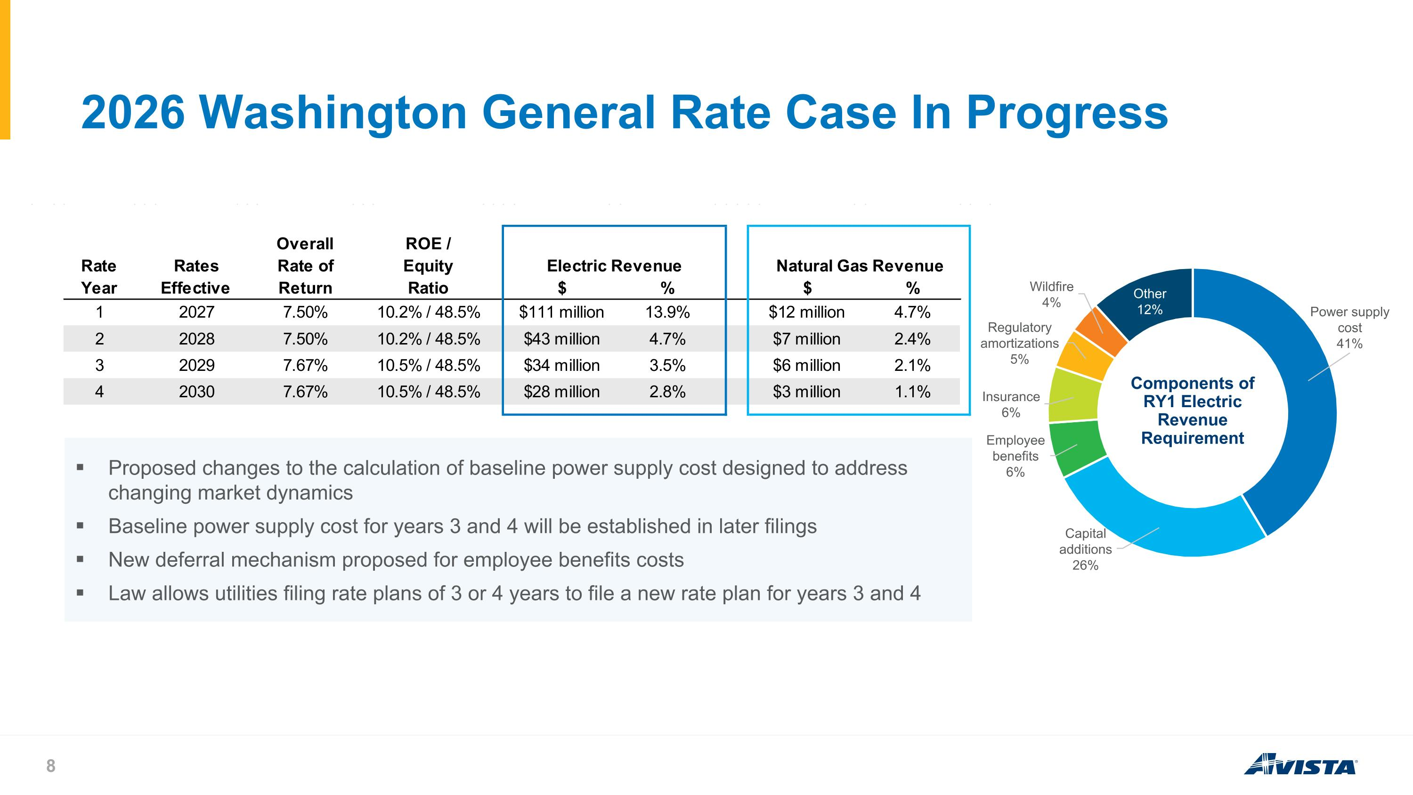
2026 Washington General Rate Case In Progress Components of RY1 Electric Revenue Requirement Proposed changes to the calculation of baseline power supply cost designed to address changing market dynamics Baseline power supply cost for years 3 and 4 will be established in later filings New deferral mechanism proposed for employee benefits costs Law allows utilities filing rate plans of 3 or 4 years to file a new rate plan for years 3 and 4

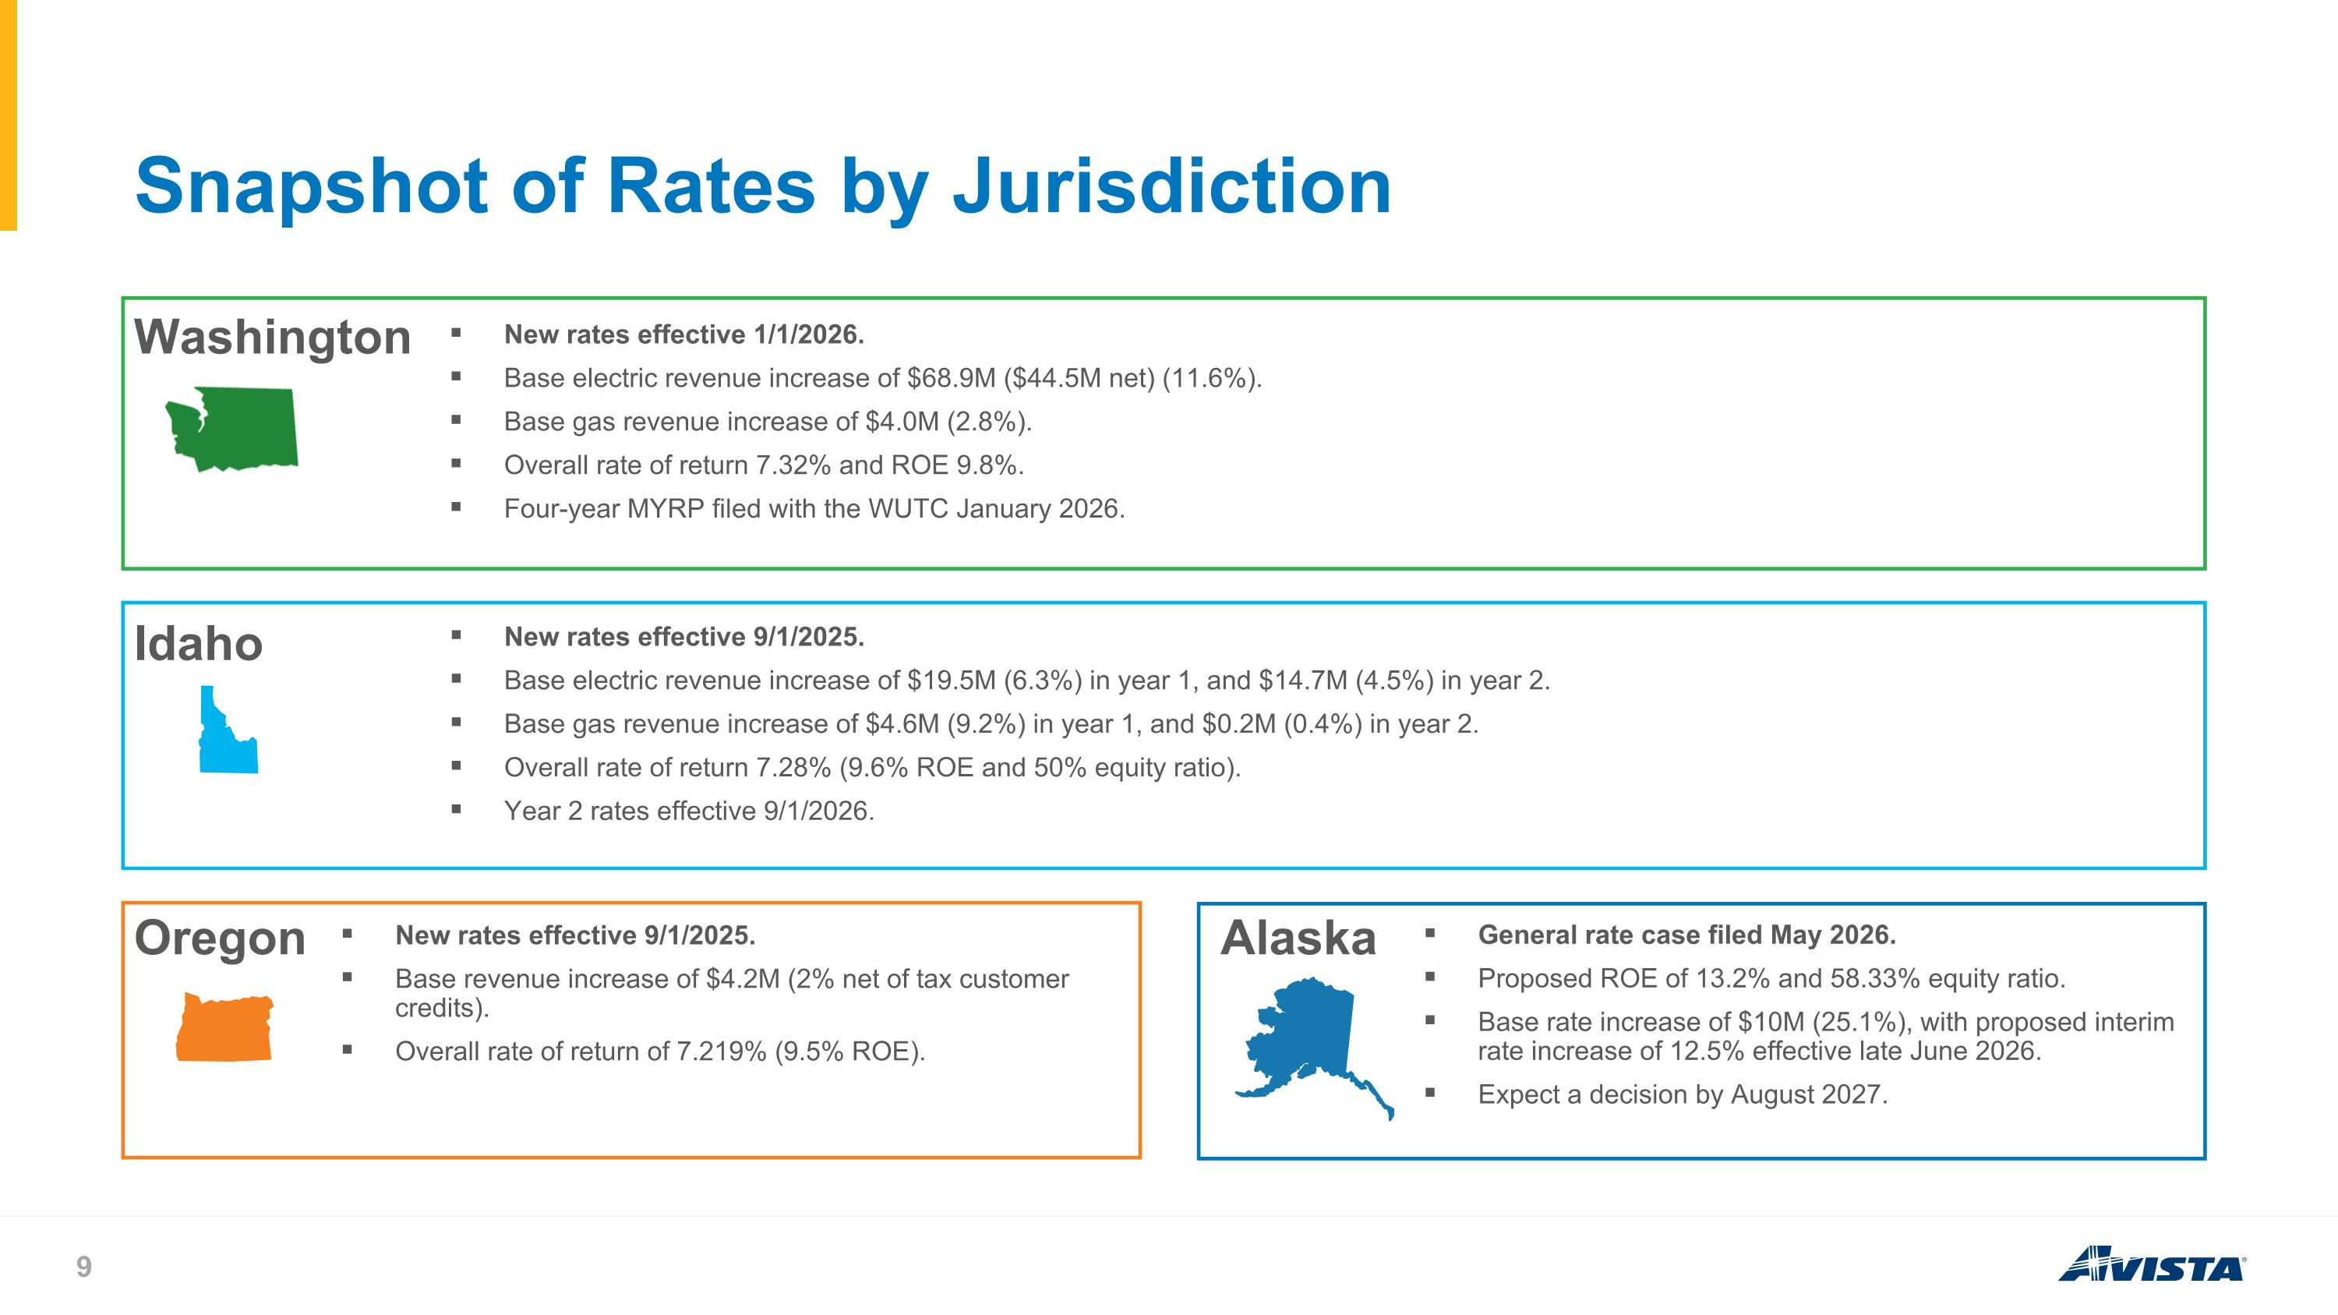
Snapshot of Rates by Jurisdiction Washington New rates effective 1/1/2026. Base electric revenue increase of $68.9M ($44.5M net) (11.6%). Base gas revenue increase of $4.0M (2.8%). Overall rate of return 7.32% and ROE 9.8%. Four-year MYRP filed with the WUTC January 2026. Idaho New rates effective 9/1/2025. Base electric revenue increase of $19.5M (6.3%) in year 1, and $14.7M (4.5%) in year 2. Base gas revenue increase of $4.6M (9.2%) in year 1, and $0.2M (0.4%) in year 2. Overall rate of return 7.28% (9.6% ROE and 50% equity ratio). Year 2 rates effective 9/1/2026. Oregon New rates effective 9/1/2025. Base revenue increase of $4.2M (2% net of tax customer credits). Overall rate of return of 7.219% (9.5% ROE). Alaska General rate case filed May 2026. Proposed ROE of 13.2% and 58.33% equity ratio. Base rate increase of $10M (25.1%), with proposed interim rate increase of 12.5% effective late June 2026. Expect a decision by August 2027.

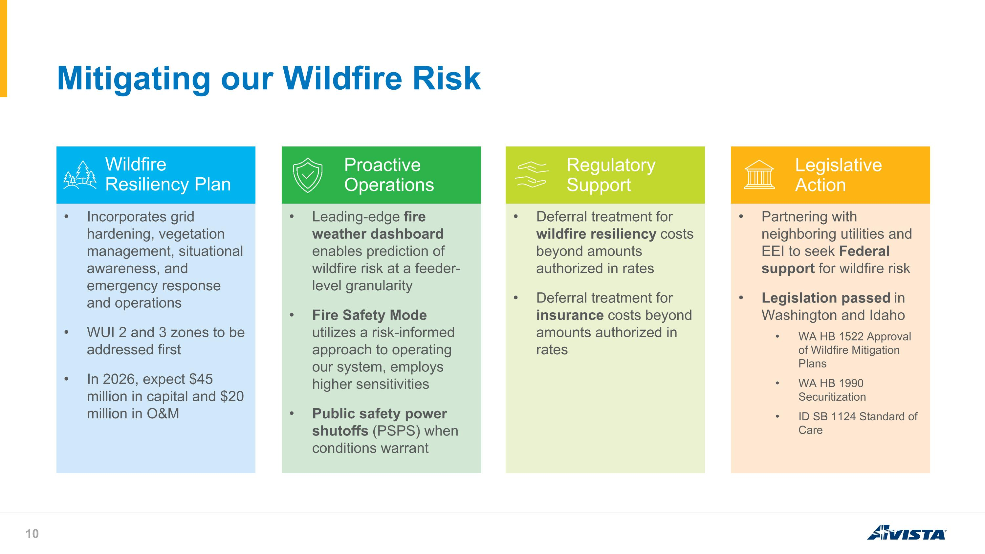
Mitigating our Wildfire Risk Incorporates grid hardening, vegetation management, situational awareness, and emergency response and operations WUI 2 and 3 zones to be addressed first In 2026, expect $45 million in capital and $20 million in O&M Leading-edge fire weather dashboard enables prediction of wildfire risk at a feeder-level granularity Fire Safety Mode utilizes a risk-informed approach to operating our system, employs higher sensitivities Public safety power shutoffs (PSPS) when conditions warrant Deferral treatment for wildfire resiliency costs beyond amounts authorized in rates Deferral treatment for insurance costs beyond amounts authorized in rates Partnering with neighboring utilities and EEI to seek Federal support for wildfire risk Legislation passed in Washington and Idaho WA HB 1522 Approval of Wildfire Mitigation Plans WA HB 1990 Securitization ID SB 1124 Standard of Care Wildfire Resiliency Plan Proactive Operations Regulatory Support Legislative Action

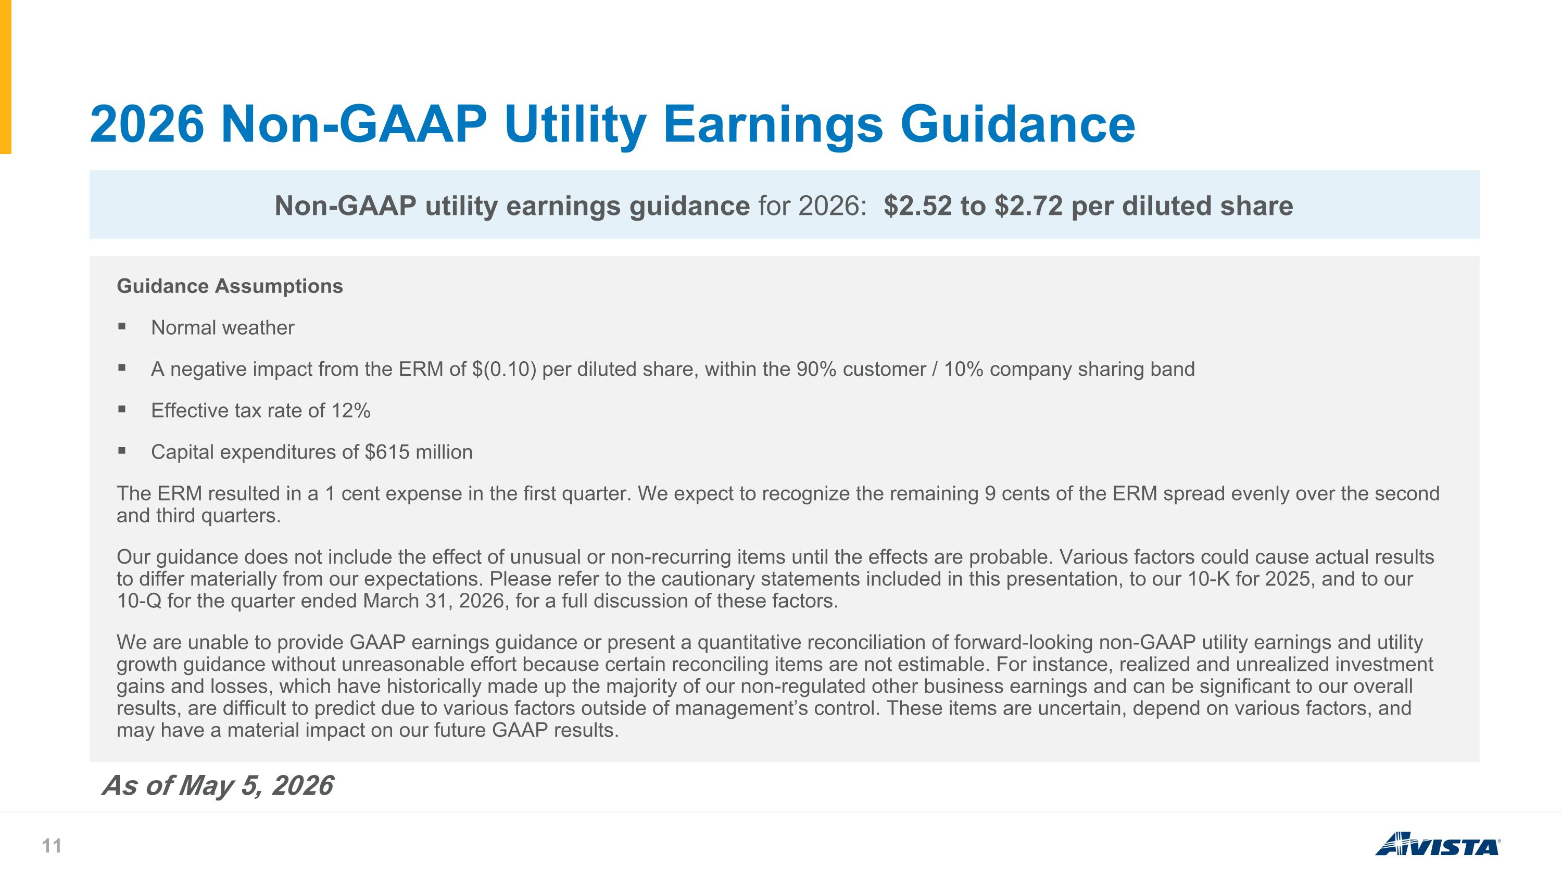
2026 Non-GAAP Utility Earnings Guidance Guidance Assumptions Normal weather A negative impact from the ERM of $(0.10) per diluted share, within the 90% customer / 10% company sharing band Effective tax rate of 12% Capital expenditures of $615 million The ERM resulted in a 1 cent expense in the first quarter. We expect to recognize the remaining 9 cents of the ERM spread evenly over the second and third quarters. Our guidance does not include the effect of unusual or non-recurring items until the effects are probable. Various factors could cause actual results to differ materially from our expectations. Please refer to the cautionary statements included in this presentation, to our 10-K for 2025, and to our 10-Q for the quarter ended March 31, 2026, for a full discussion of these factors. We are unable to provide GAAP earnings guidance or present a quantitative reconciliation of forward-looking non-GAAP utility earnings and utility growth guidance without unreasonable effort because certain reconciling items are not estimable. For instance, realized and unrealized investment gains and losses, which have historically made up the majority of our non-regulated other business earnings and can be significant to our overall results, are difficult to predict due to various factors outside of management’s control. These items are uncertain, depend on various factors, and may have a material impact on our future GAAP results. Non-GAAP utility earnings guidance for 2026: $2.52 to $2.72 per diluted share As of May 5, 2026

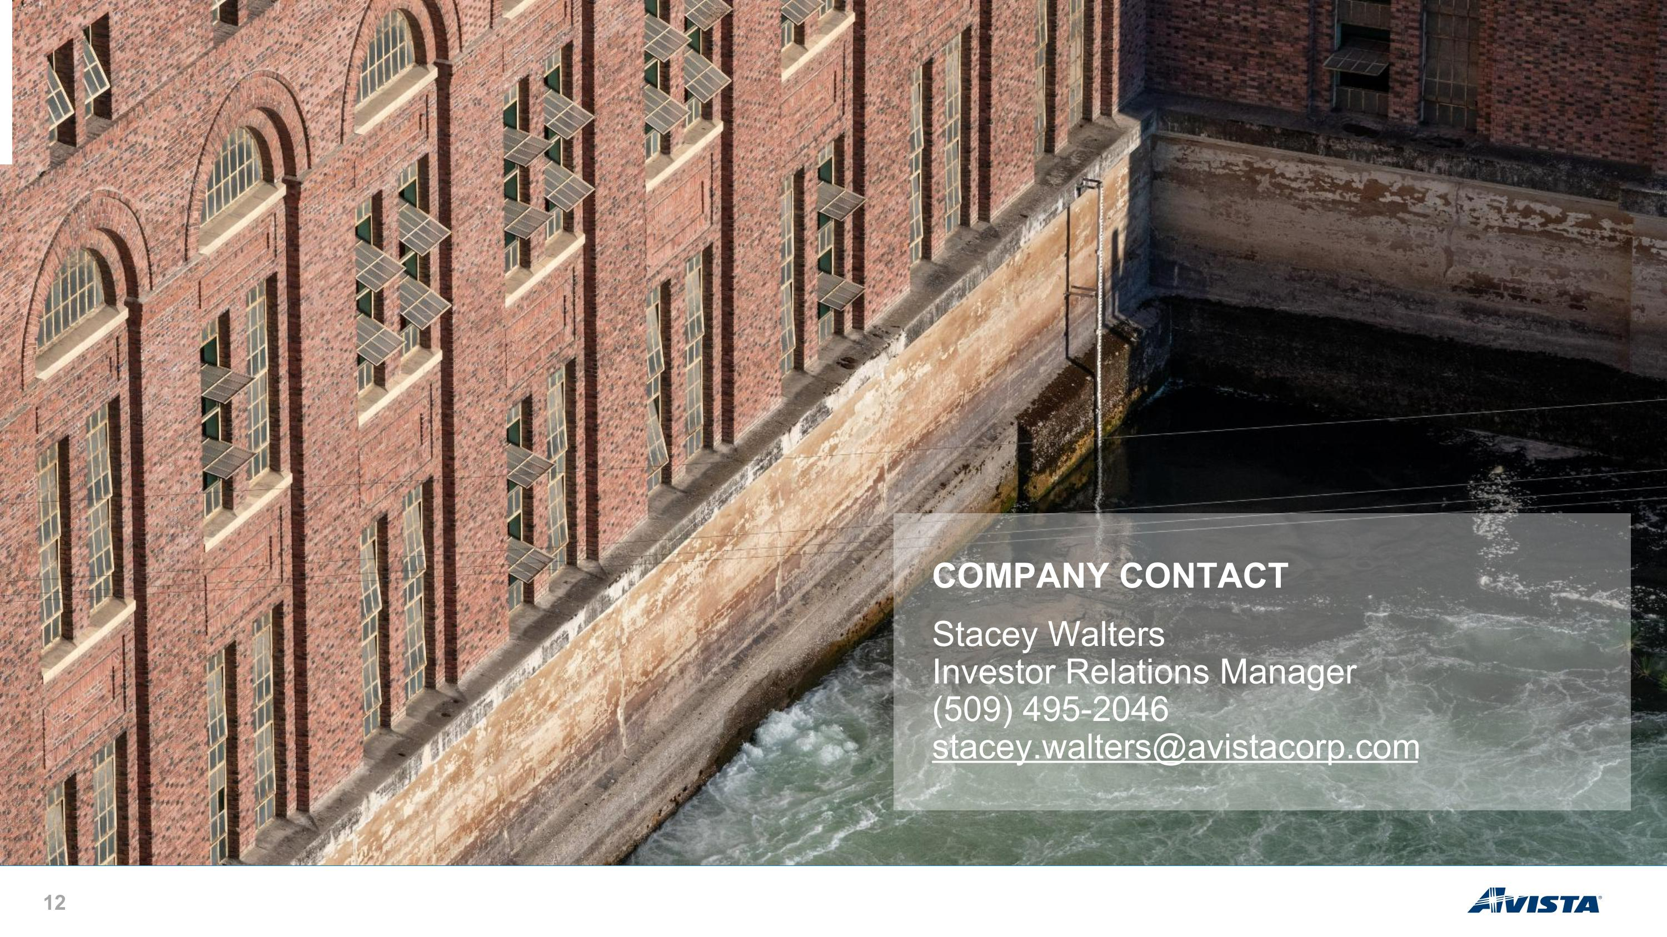
COMPANY CONTACT Stacey Walters Investor Relations Manager (509) 495-2046 stacey.walters@avistacorp.com COMPANY CONTACT Stacey Walters Investor Relations Manager (509) 495-2046 stacey.walters@avistacorp.com

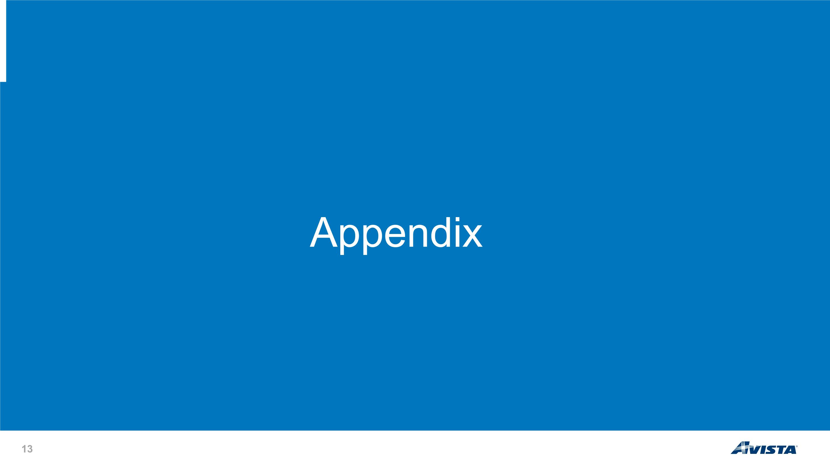
Appendix


Corporate responsibility About Avista

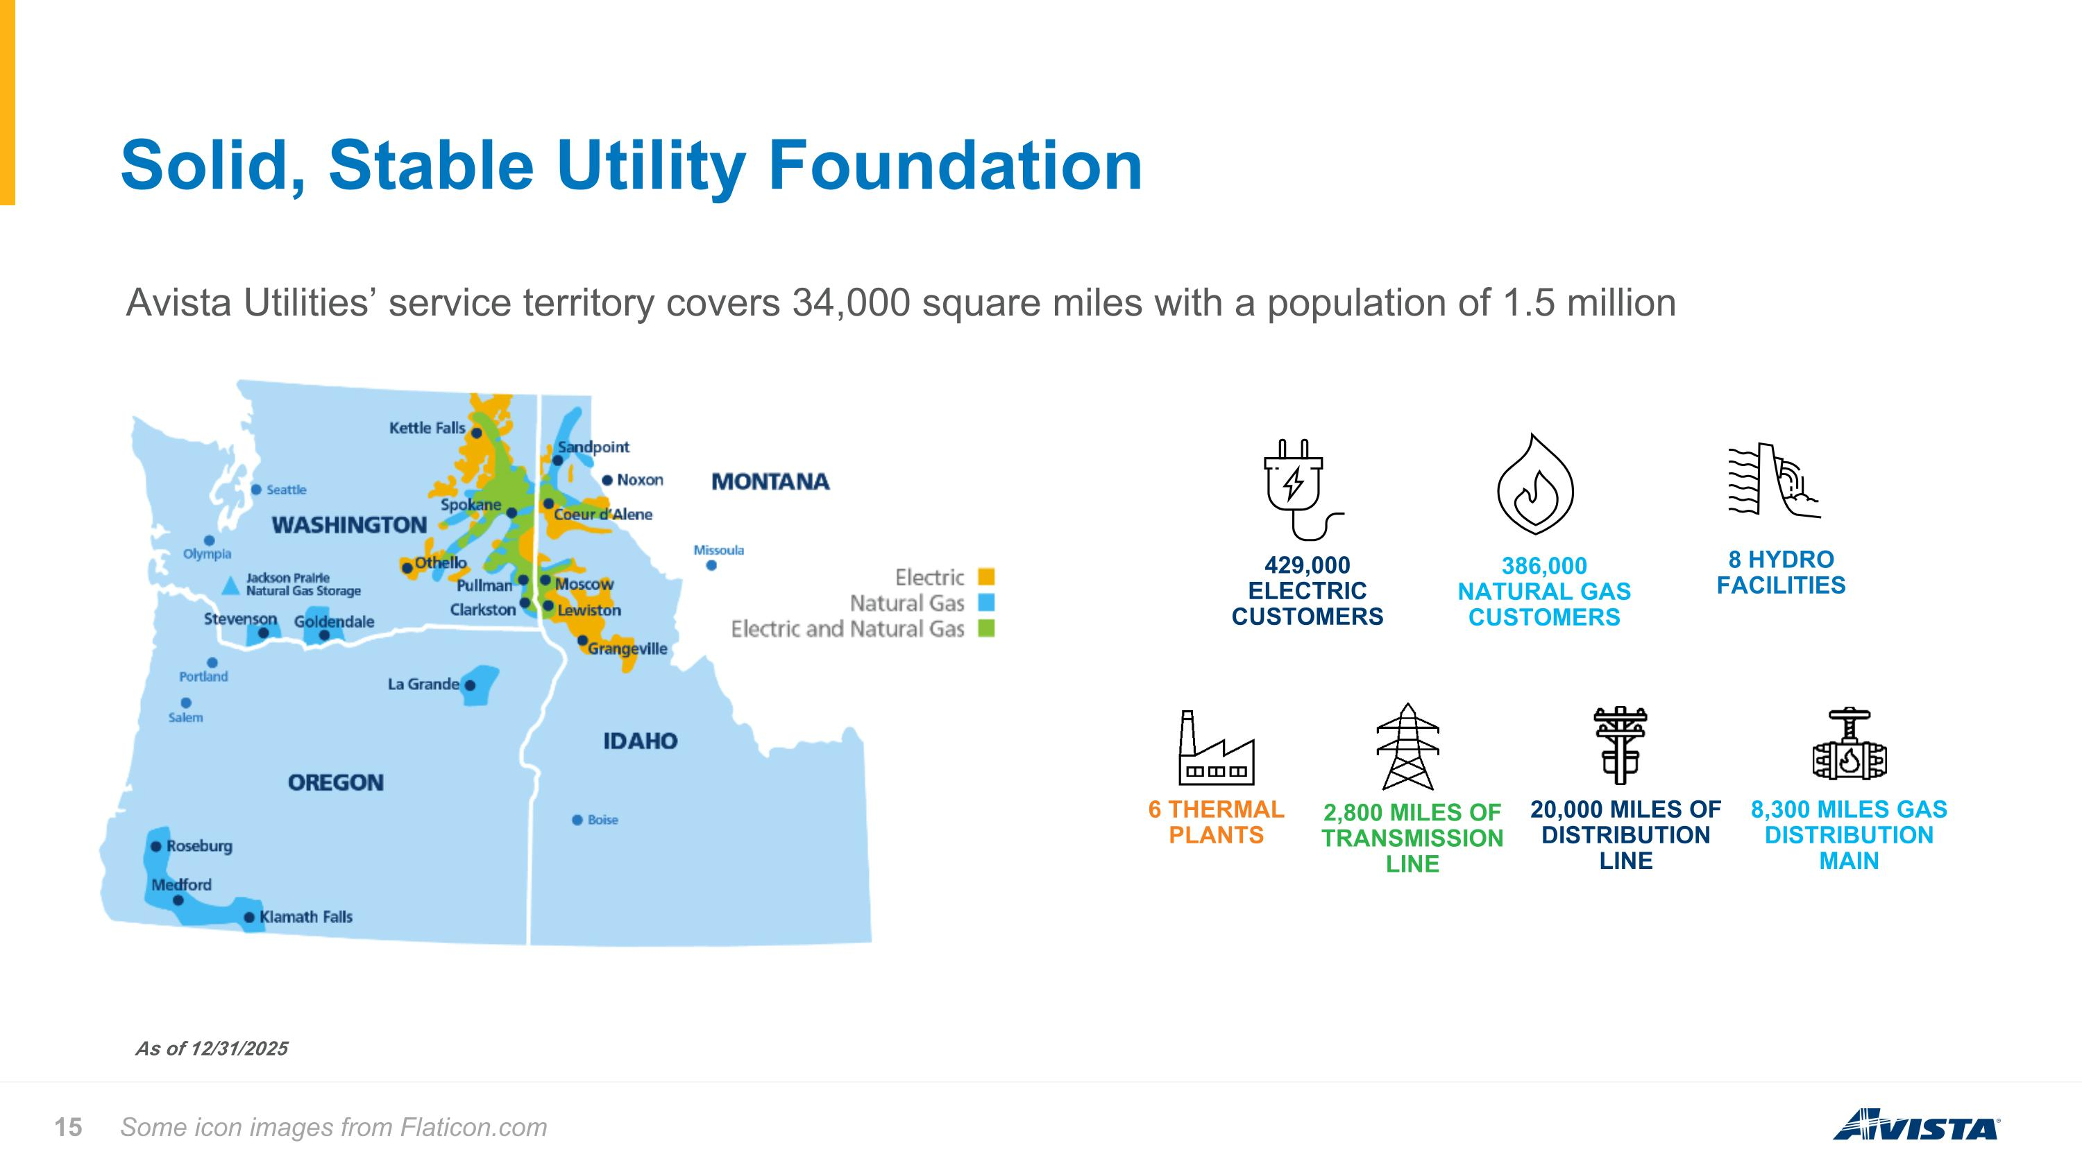
Solid, Stable Utility Foundation Some icon images from Flaticon.com As of 12/31/2025 Avista Utilities’ service territory covers 34,000 square miles with a population of 1.5 million 8 HYDRO FACILITIES 6 THERMAL PLANTS 2,800 MILES OF TRANSMISSION LINE 20,000 MILES OF DISTRIBUTION LINE 8,300 MILES GAS DISTRIBUTION MAIN 386,000 NATURAL GAS CUSTOMERS 429,000 ELECTRIC CUSTOMERS

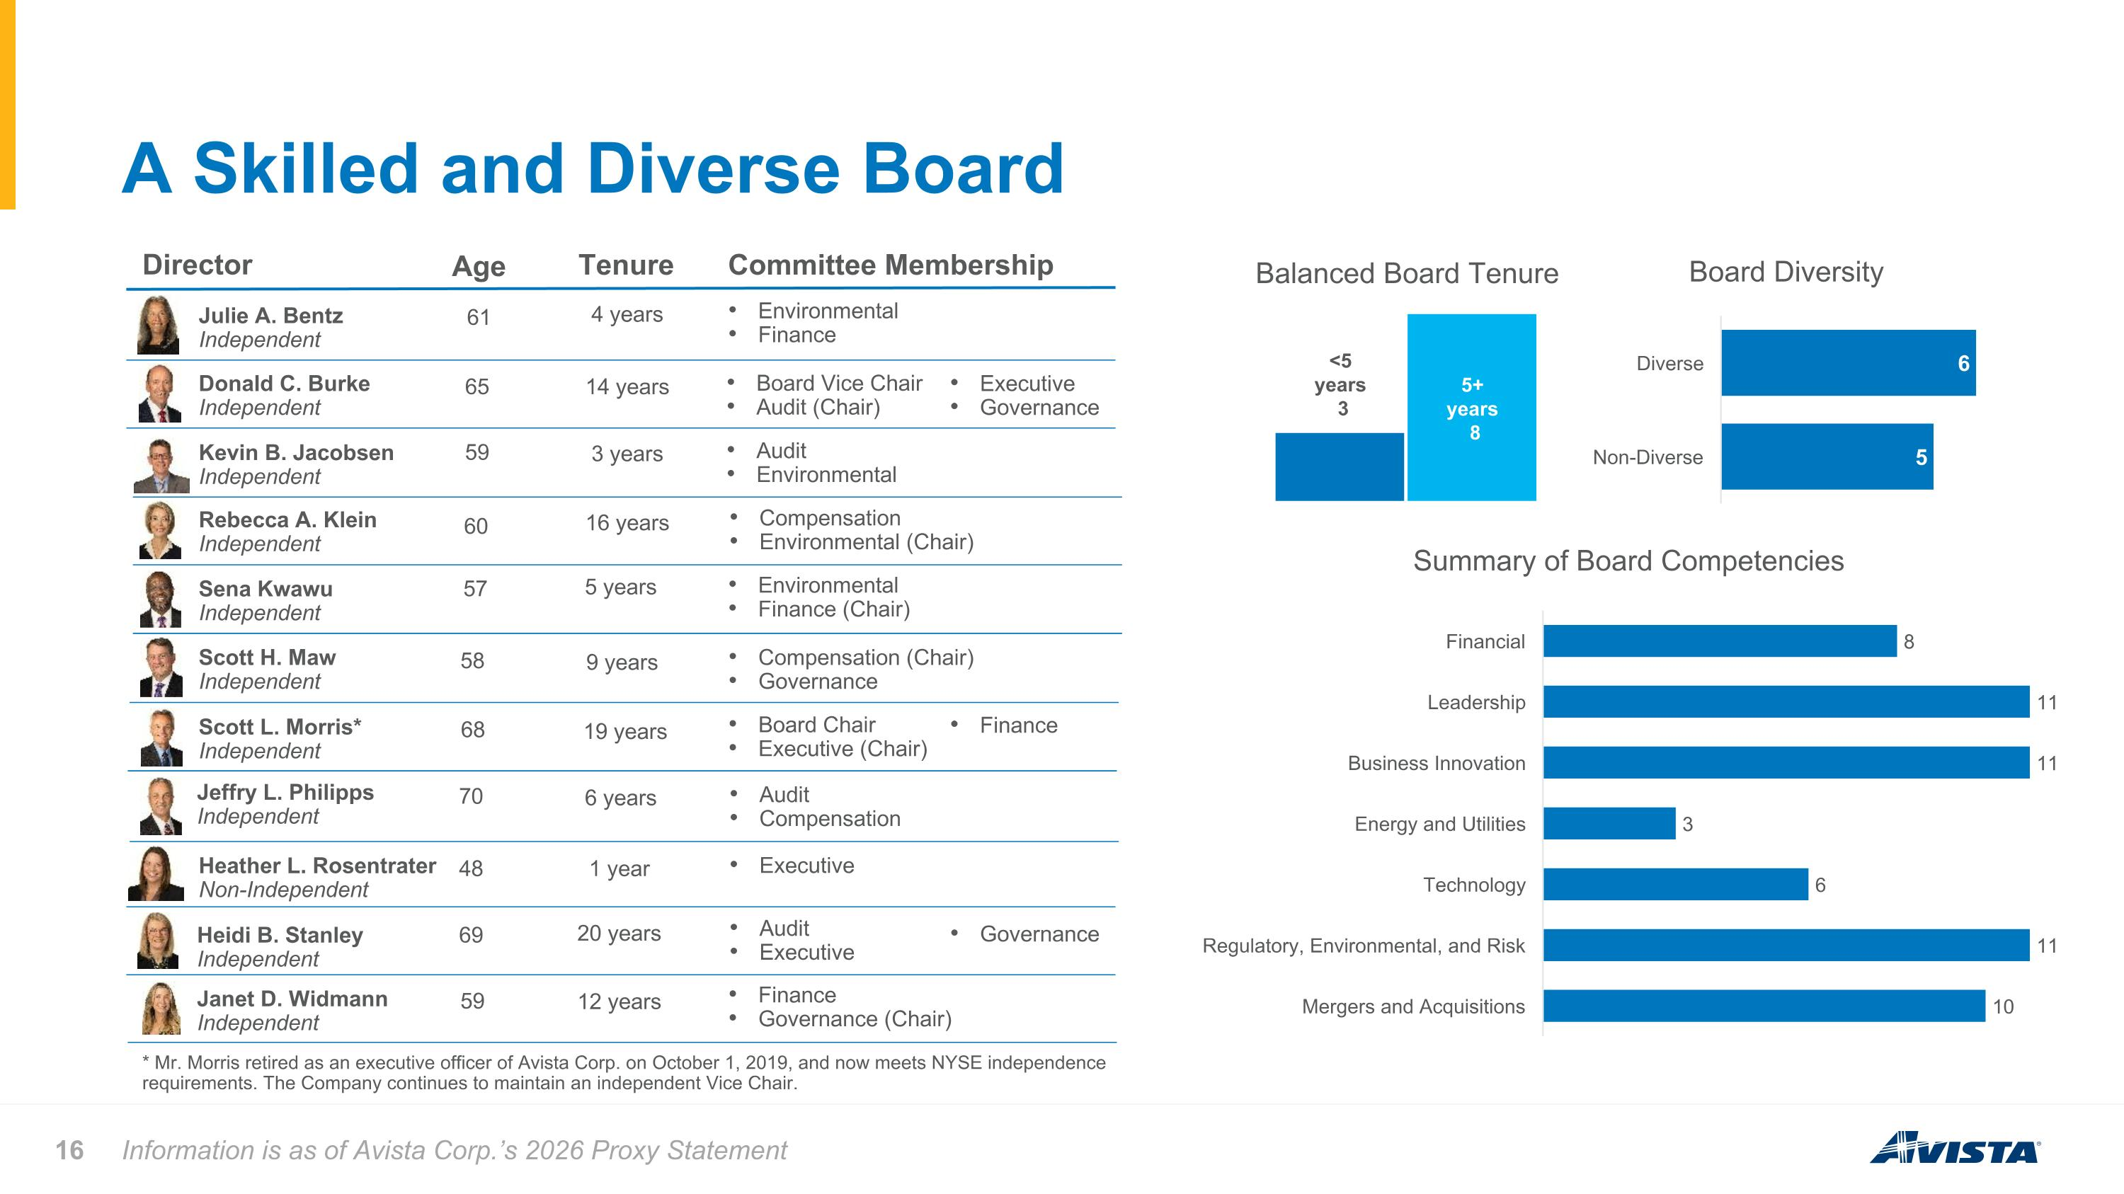
A Skilled and Diverse Board Information is as of Avista Corp.’s 2026 Proxy Statement Summary of Board Competencies Environmental Finance * Mr. Morris retired as an executive officer of Avista Corp. on October 1, 2019, and now meets NYSE independence requirements. The Company continues to maintain an independent Vice Chair. Balanced Board Tenure Board Diversity Director Age Julie A. Bentz Independent Tenure Committee Membership Donald C. Burke Independent Kevin B. Jacobsen Independent Rebecca A. Klein Independent Sena Kwawu Independent Scott H. Maw Independent Scott L. Morris* Independent Jeffry L. Philipps Independent Heather L. Rosentrater Non-Independent Janet D. Widmann Independent 61 65 59 60 57 58 68 70 48 59 4 years 14 years 3 years 16 years 5 years 9 years 19 years 6 years 1 year 12 years Board Vice Chair Audit (Chair) Audit Environmental Compensation Environmental (Chair) Environmental Finance (Chair) Compensation (Chair) Governance Board Chair Executive (Chair) Audit Compensation Executive Finance Governance (Chair) Executive Governance Finance Governance Audit Executive 20 years 69 Heidi B. Stanley Independent

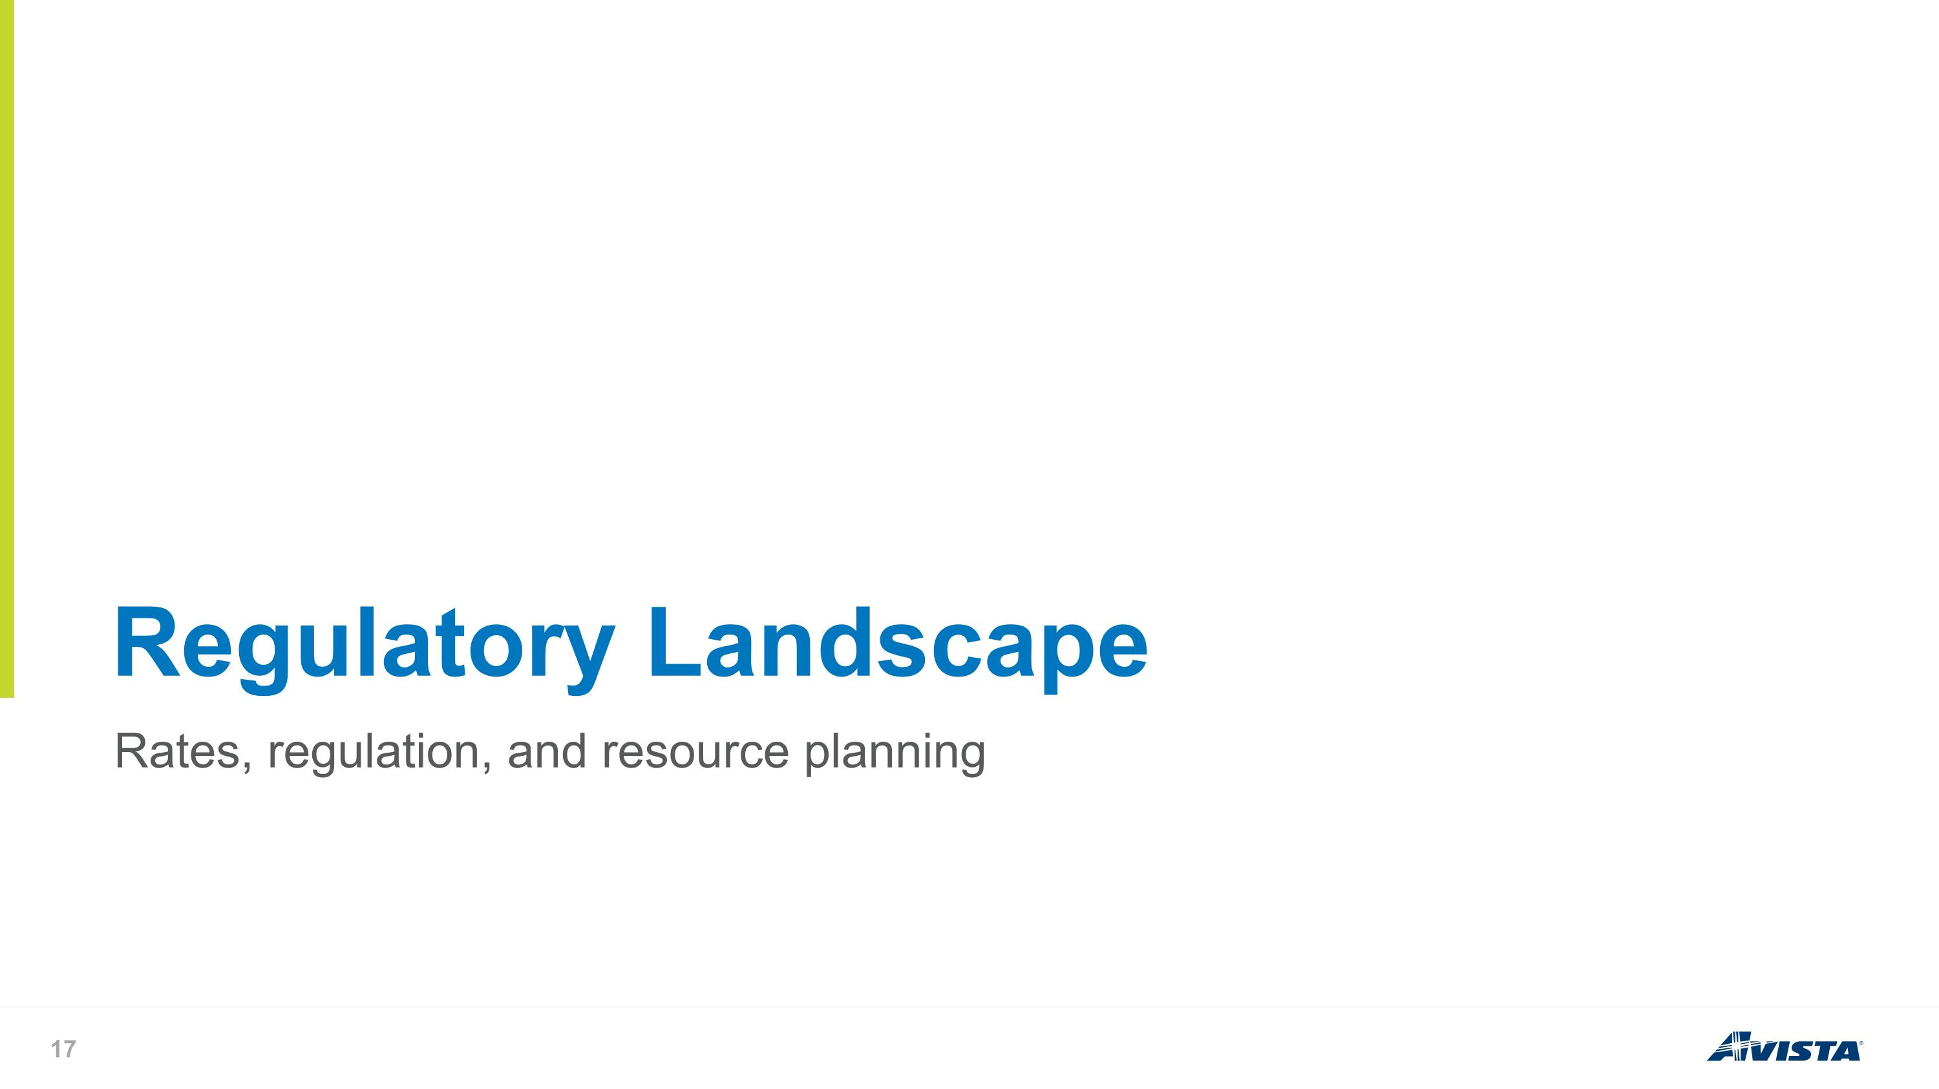
Rates, regulation, and resource planning Regulatory Landscape

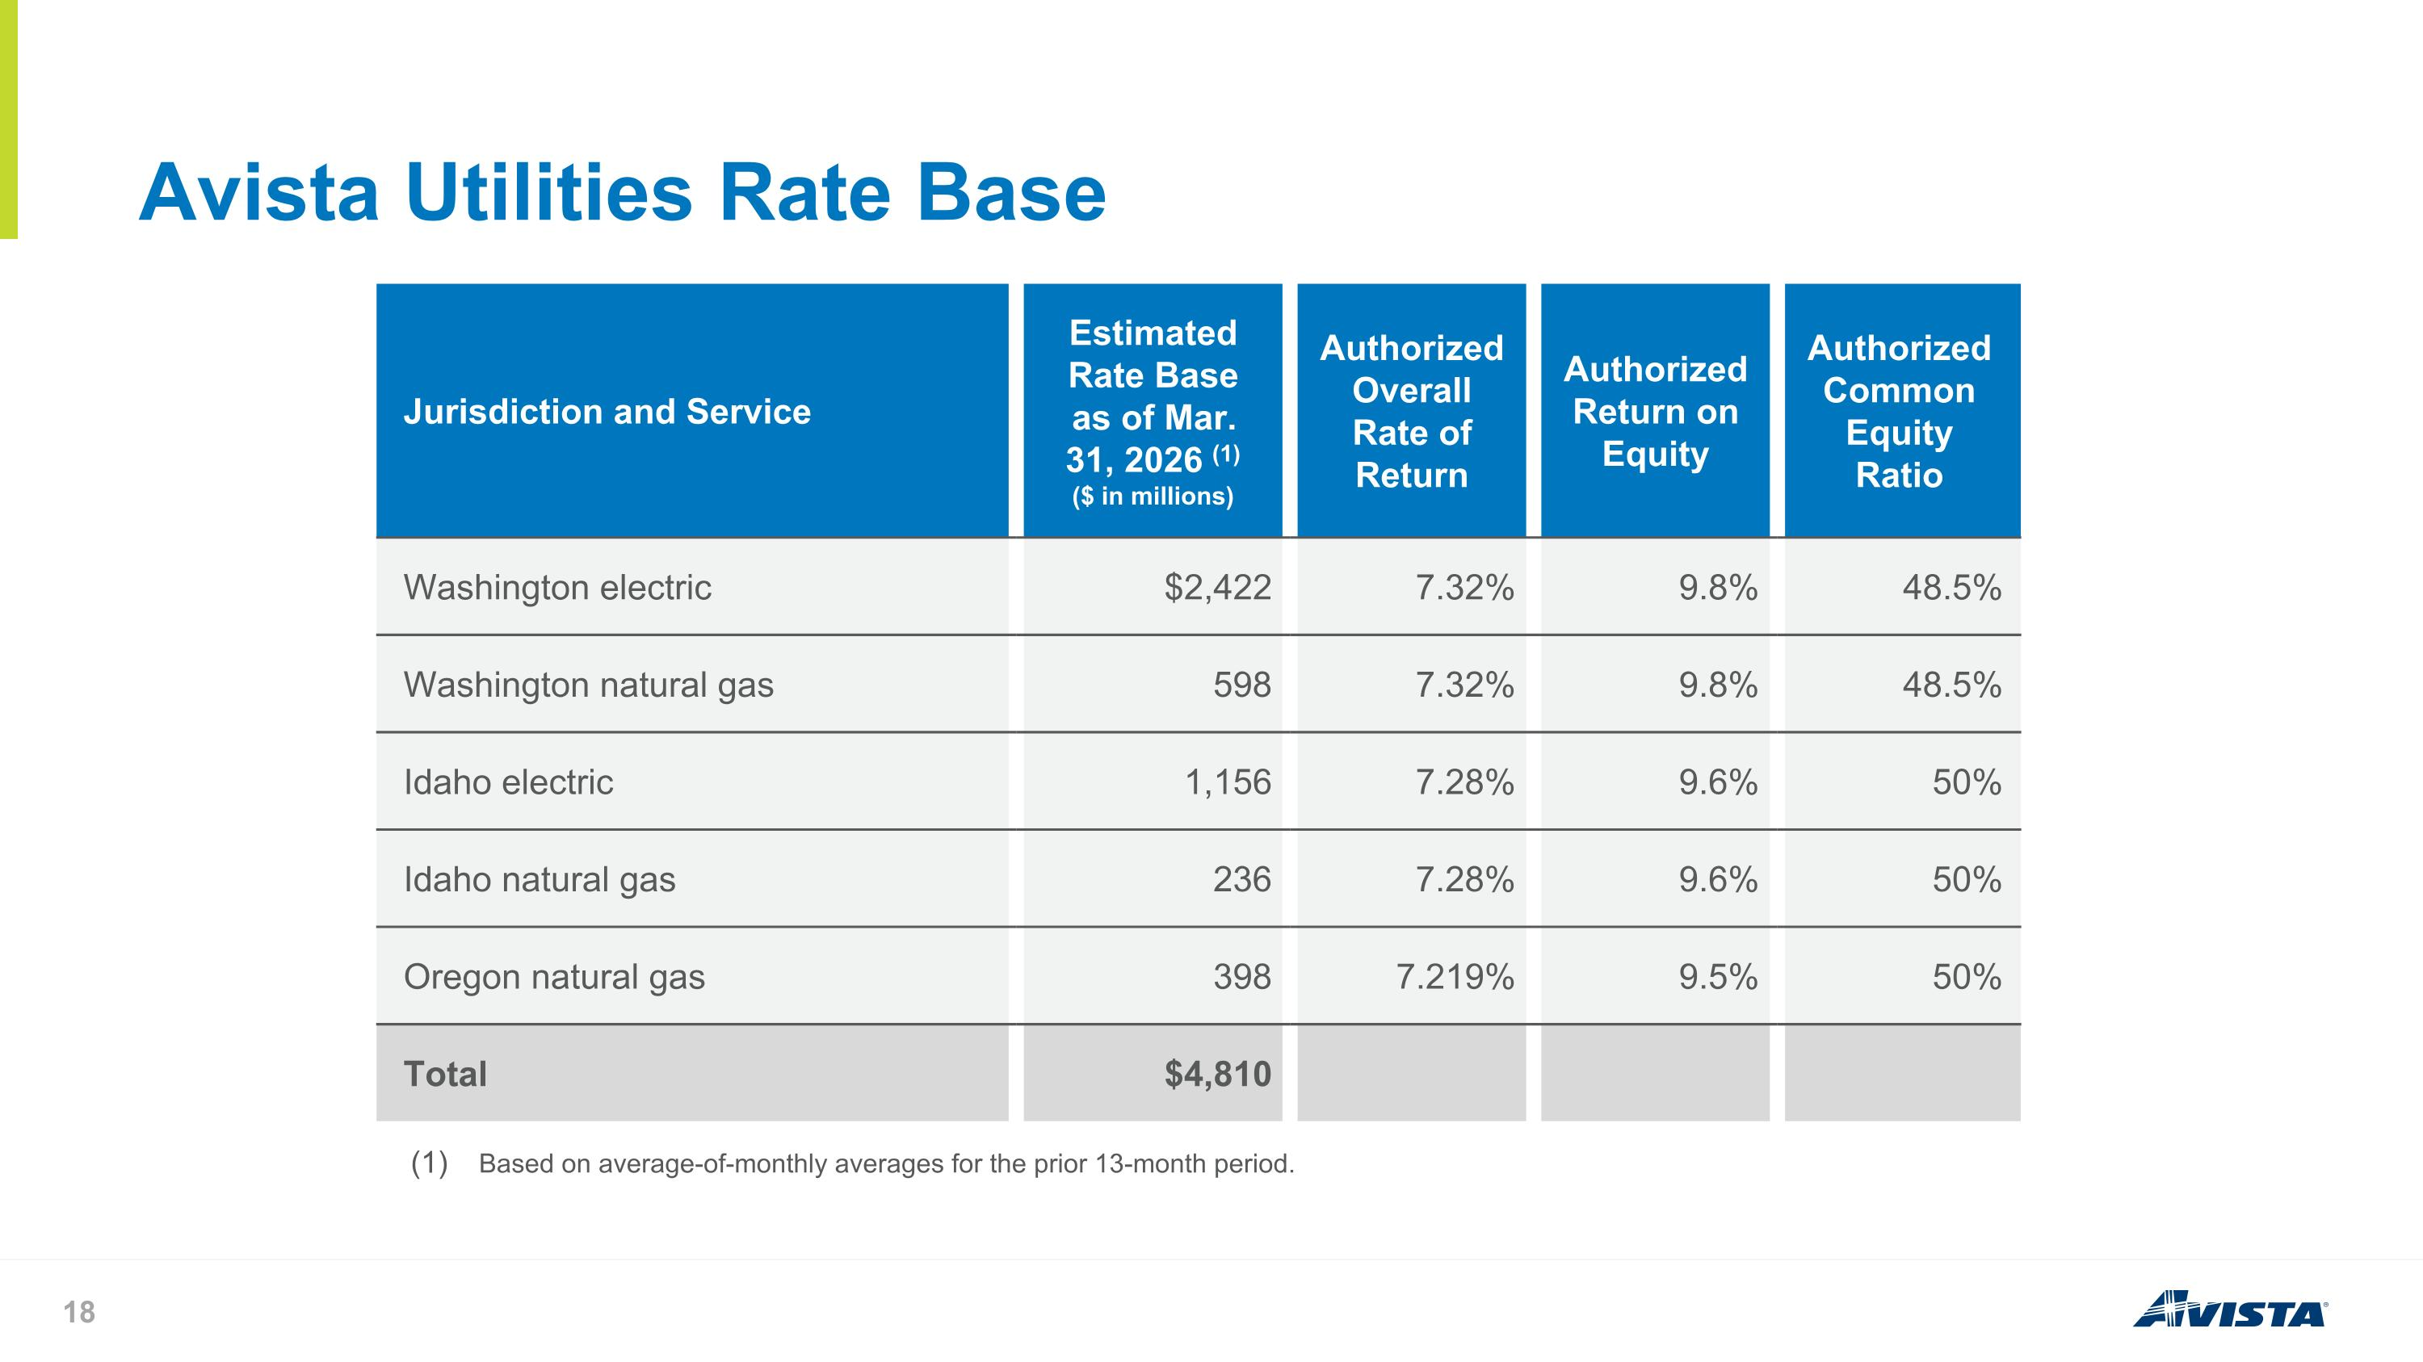
Avista Utilities Rate Base Jurisdiction and Service Estimated Rate Base as of Mar. 31, 2026 (1) ($ in millions) Authorized Overall Rate of Return Authorized Return on Equity Authorized Common Equity Ratio Washington electric $2,422 7.32% 9.8% 48.5% Washington natural gas 598 7.32% 9.8% 48.5% Idaho electric 1,156 7.28% 9.6% 50% Idaho natural gas 236 7.28% 9.6% 50% Oregon natural gas 398 7.219% 9.5% 50% Total $4,810 Based on average-of-monthly averages for the prior 13-month period.

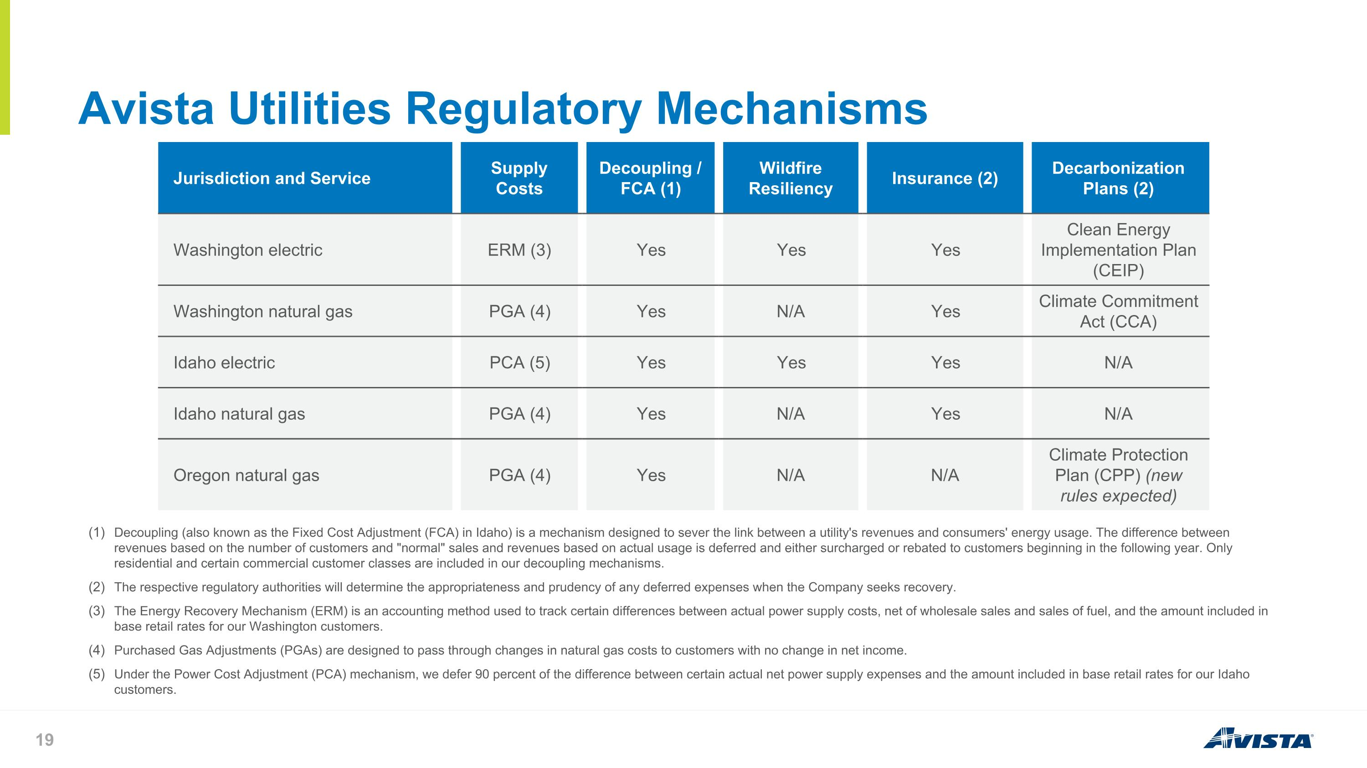
Avista Utilities Regulatory Mechanisms Jurisdiction and Service Supply Costs Decoupling / FCA (1) Wildfire Resiliency Insurance (2) Decarbonization Plans (2) Washington electric ERM (3) Yes Yes Yes Clean Energy Implementation Plan (CEIP) Washington natural gas PGA (4) Yes N/A Yes Climate Commitment Act (CCA) Idaho electric PCA (5) Yes Yes Yes N/A Idaho natural gas PGA (4) Yes N/A Yes N/A Oregon natural gas PGA (4) Yes N/A N/A Climate Protection Plan (CPP) (new rules expected) Decoupling (also known as the Fixed Cost Adjustment (FCA) in Idaho) is a mechanism designed to sever the link between a utility's revenues and consumers' energy usage. The difference between revenues based on the number of customers and "normal" sales and revenues based on actual usage is deferred and either surcharged or rebated to customers beginning in the following year. Only residential and certain commercial customer classes are included in our decoupling mechanisms. The respective regulatory authorities will determine the appropriateness and prudency of any deferred expenses when the Company seeks recovery. The Energy Recovery Mechanism (ERM) is an accounting method used to track certain differences between actual power supply costs, net of wholesale sales and sales of fuel, and the amount included in base retail rates for our Washington customers. Purchased Gas Adjustments (PGAs) are designed to pass through changes in natural gas costs to customers with no change in net income. Under the Power Cost Adjustment (PCA) mechanism, we defer 90 percent of the difference between certain actual net power supply expenses and the amount included in base retail rates for our Idaho customers.

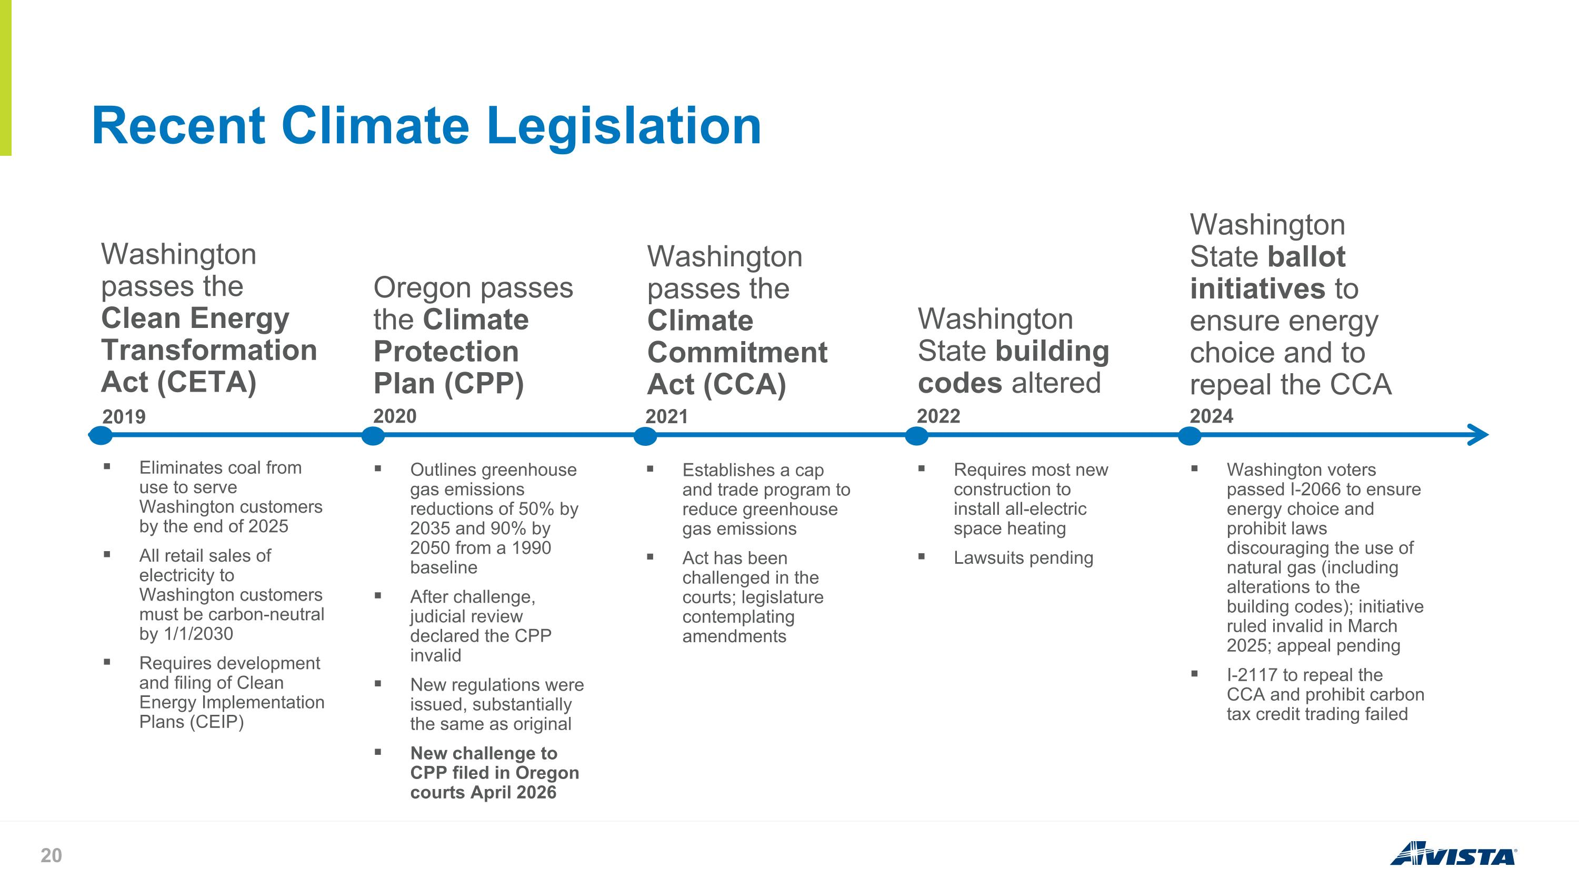
Recent Climate Legislation 2019 Washington passes the Clean Energy Transformation Act (CETA) Eliminates coal from use to serve Washington customers by the end of 2025 All retail sales of electricity to Washington customers must be carbon-neutral by 1/1/2030 Requires development and filing of Clean Energy Implementation Plans (CEIP) 2020 Oregon passes the Climate Protection Plan (CPP) Outlines greenhouse gas emissions reductions of 50% by 2035 and 90% by 2050 from a 1990 baseline After challenge, judicial review declared the CPP invalid New regulations were issued, substantially the same as original New challenge to CPP filed in Oregon courts April 2026 2021 Washington passes the Climate Commitment Act (CCA) Establishes a cap and trade program to reduce greenhouse gas emissions Act has been challenged in the courts; legislature contemplating amendments 2022 Washington State building codes altered Requires most new construction to install all-electric space heating Lawsuits pending 2024 Washington State ballot initiatives to ensure energy choice and to repeal the CCA Washington voters passed I-2066 to ensure energy choice and prohibit laws discouraging the use of natural gas (including alterations to the building codes); initiative ruled invalid in March 2025; appeal pending I-2117 to repeal the CCA and prohibit carbon tax credit trading failed

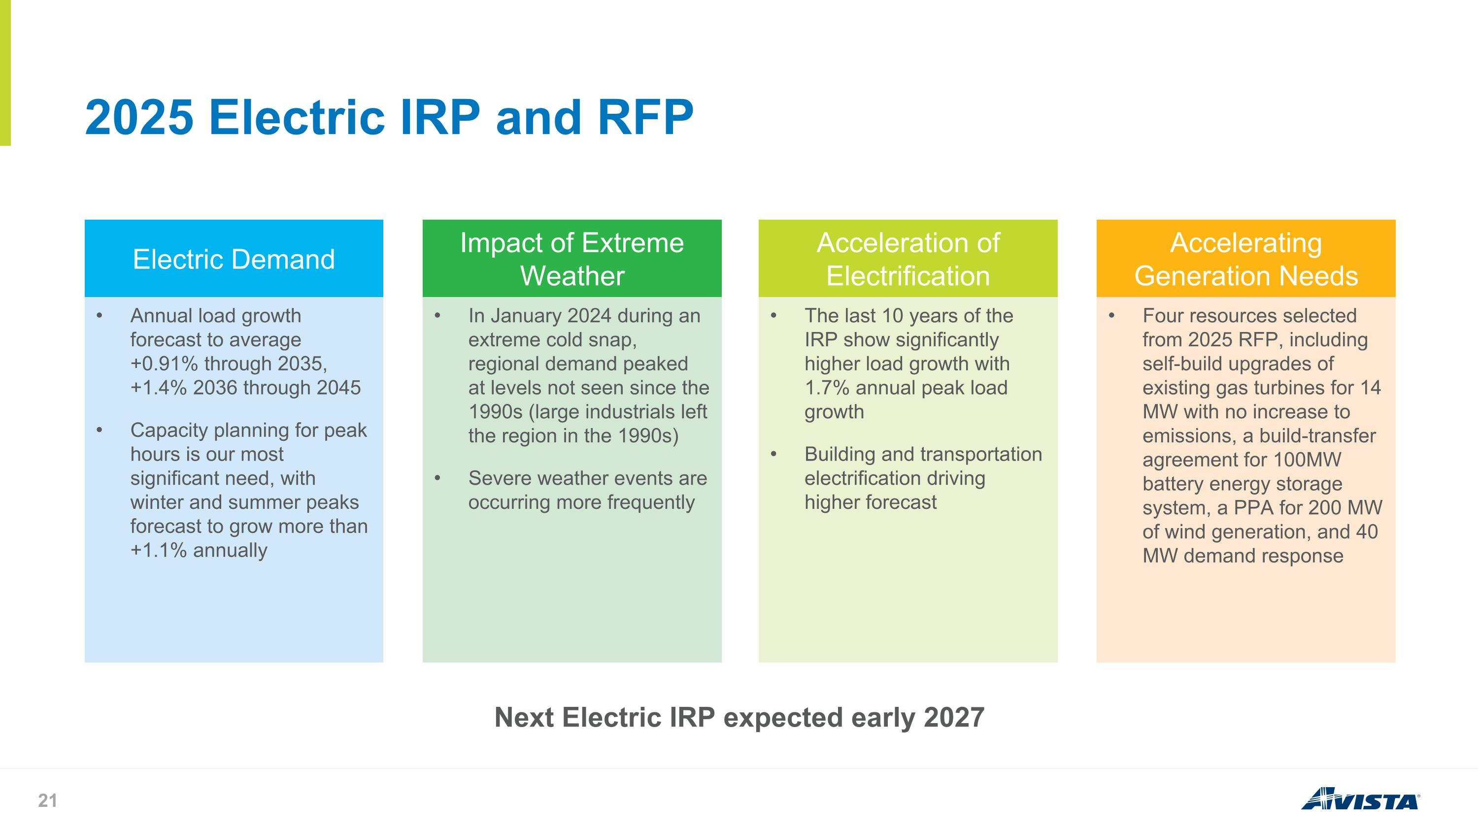
2025 Electric IRP and RFP Electric Demand Annual load growth forecast to average +0.91% through 2035, +1.4% 2036 through 2045 Capacity planning for peak hours is our most significant need, with winter and summer peaks forecast to grow more than +1.1% annually Impact of Extreme Weather In January 2024 during an extreme cold snap, regional demand peaked at levels not seen since the 1990s (large industrials left the region in the 1990s) Severe weather events are occurring more frequently Acceleration of Electrification The last 10 years of the IRP show significantly higher load growth with 1.7% annual peak load growth Building and transportation electrification driving higher forecast Accelerating Generation Needs Four resources selected from 2025 RFP, including self-build upgrades of existing gas turbines for 14 MW with no increase to emissions, a build-transfer agreement for 100MW battery energy storage system, a PPA for 200 MW of wind generation, and 40 MW demand response Next Electric IRP expected early 2027

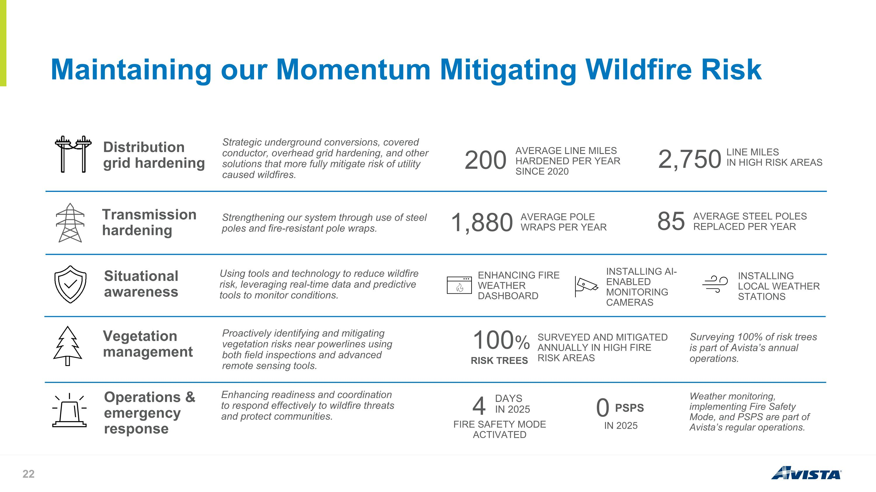
Maintaining our Momentum Mitigating Wildfire Risk Distribution grid hardening Strategic underground conversions, covered conductor, overhead grid hardening, and other solutions that more fully mitigate risk of utility caused wildfires. Operations & emergency response Enhancing readiness and coordination to respond effectively to wildfire threats and protect communities. Vegetation management Proactively identifying and mitigating vegetation risks near powerlines using both field inspections and advanced remote sensing tools. 200 AVERAGE LINE MILES HARDENED PER YEAR SINCE 2020 Transmission hardening Strengthening our system through use of steel poles and fire-resistant pole wraps. Situational awareness Using tools and technology to reduce wildfire risk, leveraging real-time data and predictive tools to monitor conditions. 100% SURVEYED AND MITIGATED ANNUALLY IN HIGH FIRE RISK AREAS DAYS IN 2025 1,880 AVERAGE POLE WRAPS PER YEAR Surveying 100% of risk trees is part of Avista’s annual operations. 2,750 LINE MILES IN HIGH RISK AREAS 85 AVERAGE STEEL POLES REPLACED PER YEAR RISK TREES 4 FIRE SAFETY MODE ACTIVATED Weather monitoring, implementing Fire Safety Mode, and PSPS are part of Avista’s regular operations. 0 PSPS ENHANCING FIRE WEATHER DASHBOARD INSTALLING AI-ENABLED MONITORING CAMERAS INSTALLING LOCAL WEATHER STATIONS IN 2025

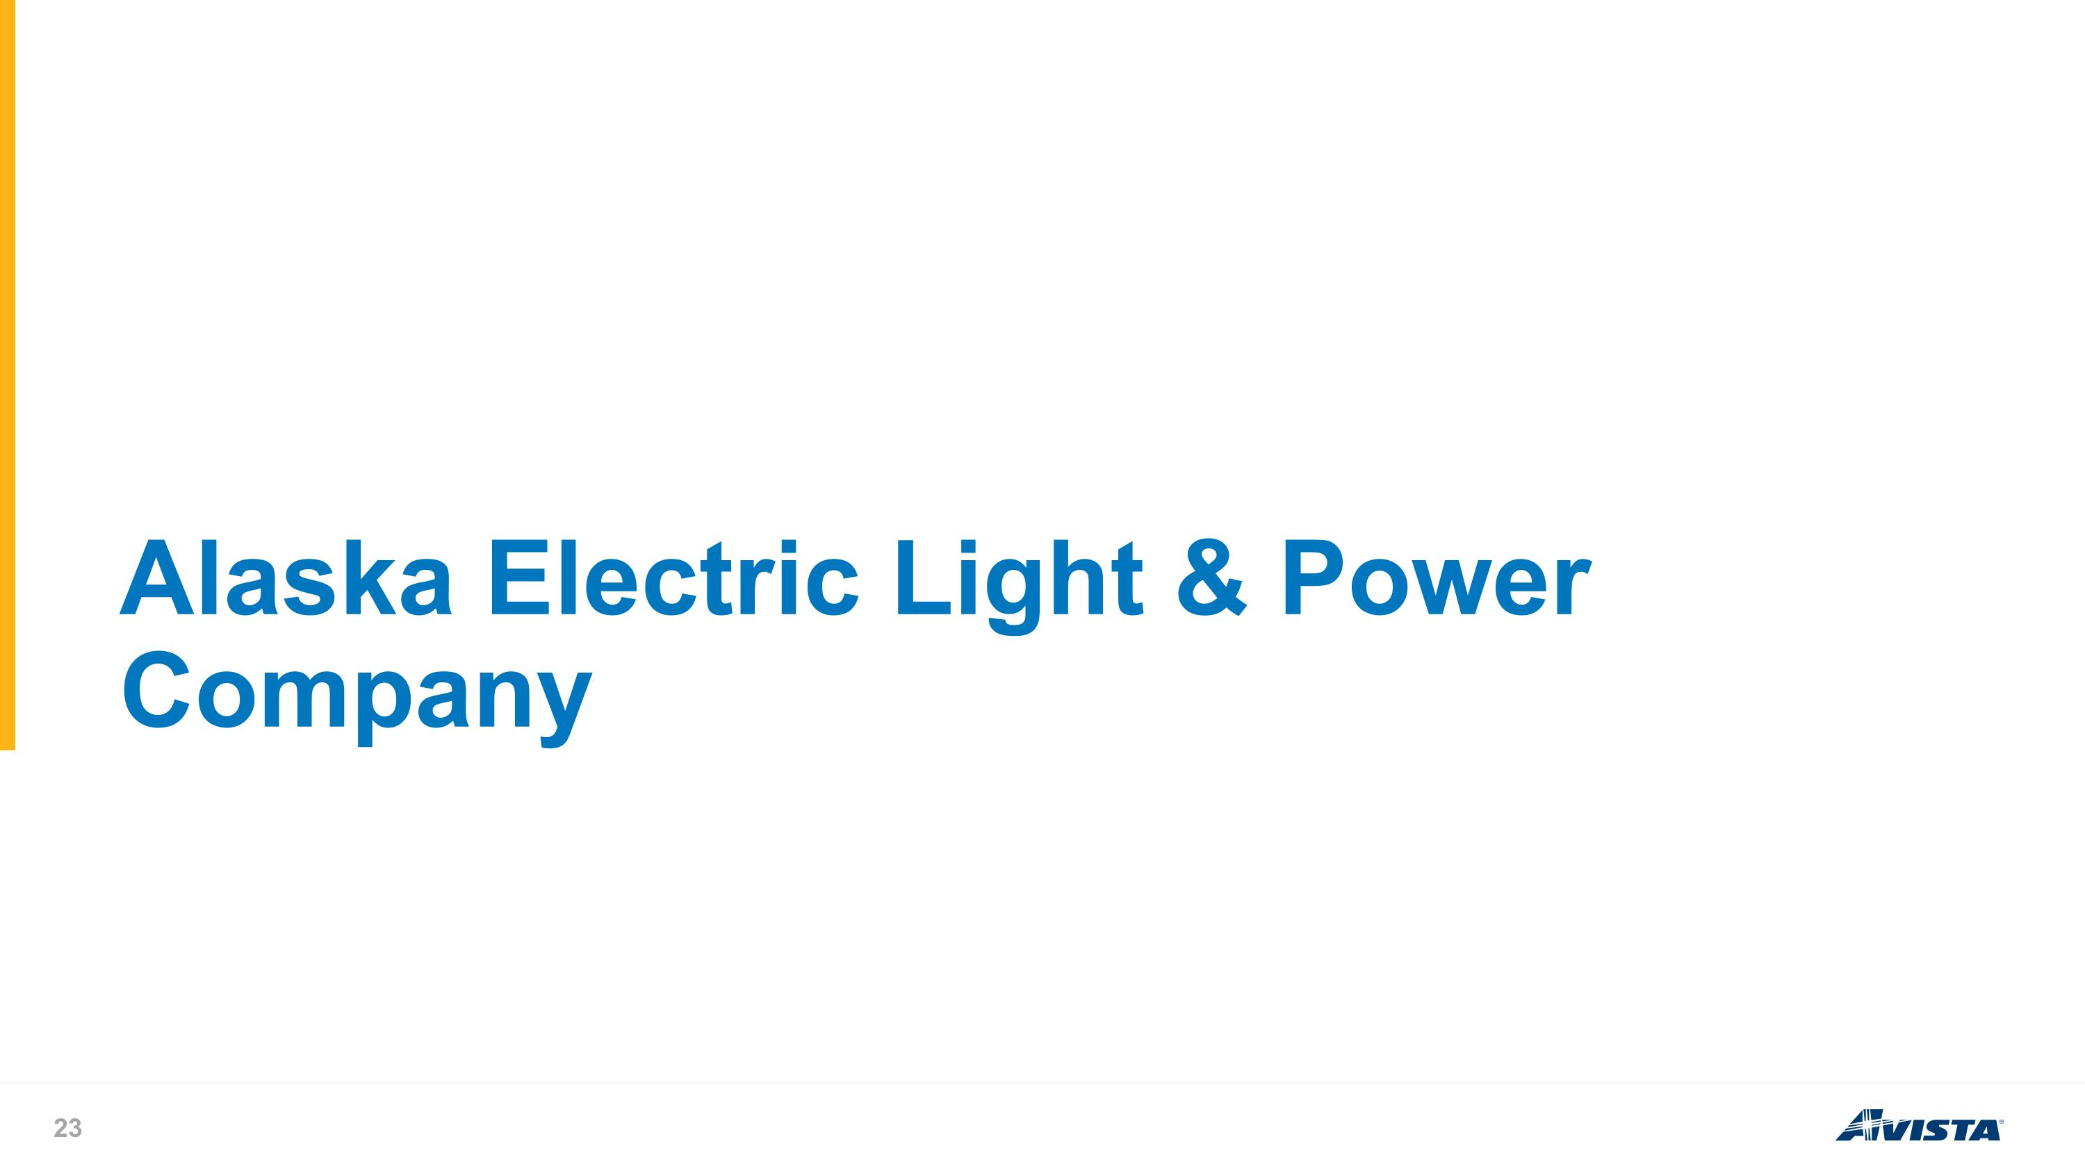
Alaska Electric Light & Power Company

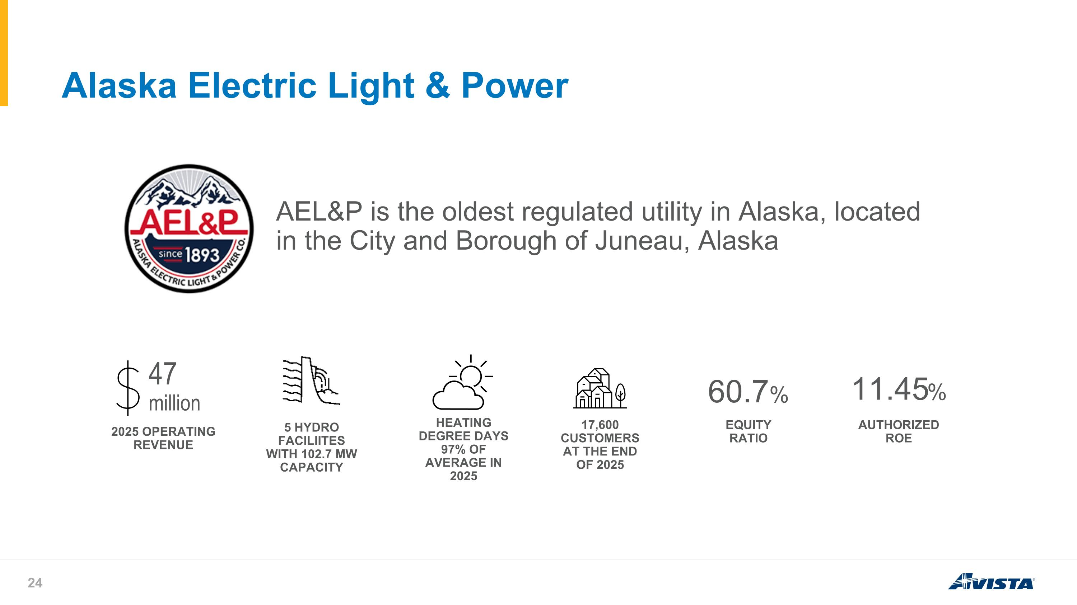
Alaska Electric Light & Power AEL&P is the oldest regulated utility in Alaska, located in the City and Borough of Juneau, Alaska 60.7% 11.45% 47 million 2025 OPERATING REVENUE 5 HYDRO FACILIITES WITH 102.7 MW CAPACITY HEATING DEGREE DAYS 97% OF AVERAGE IN 2025 17,600 CUSTOMERS AT THE END OF 2025 EQUITY RATIO AUTHORIZED ROE

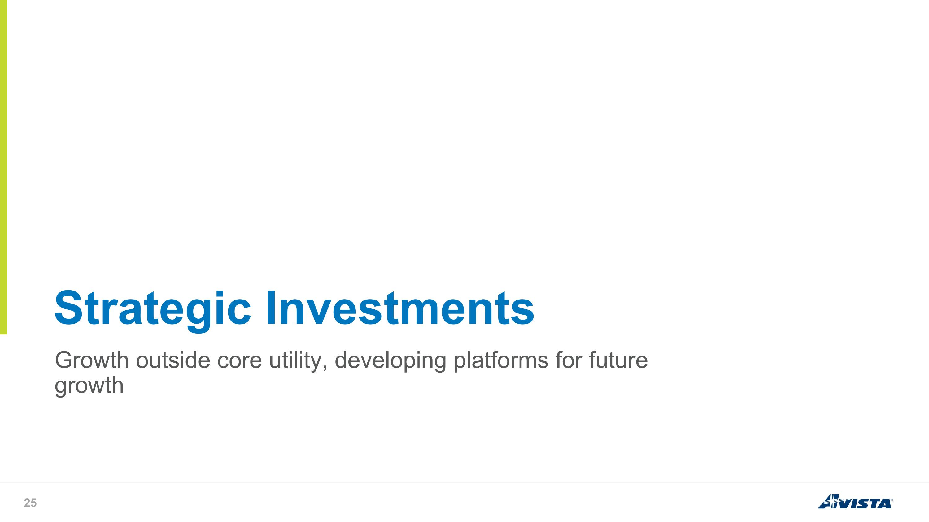
Growth outside core utility, developing platforms for future growth Strategic Investments

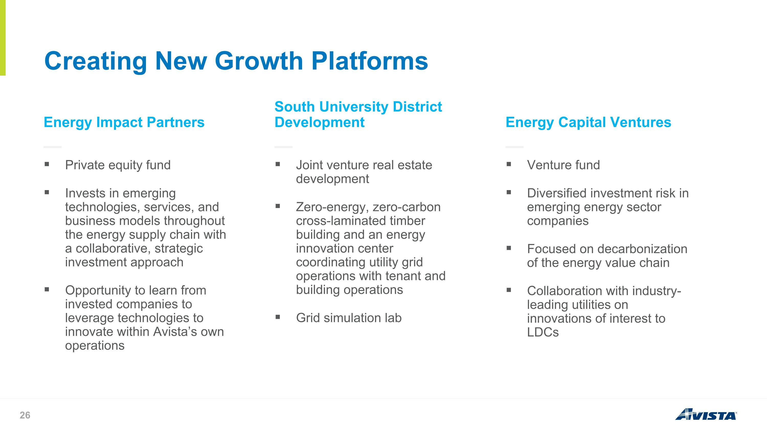
Creating New Growth Platforms Private equity fund Invests in emerging technologies, services, and business models throughout the energy supply chain with a collaborative, strategic investment approach Opportunity to learn from invested companies to leverage technologies to innovate within Avista’s own operations Energy Impact Partners Joint venture real estate development Zero-energy, zero-carbon cross-laminated timber building and an energy innovation center coordinating utility grid operations with tenant and building operations Grid simulation lab South University District Development Venture fund Diversified investment risk in emerging energy sector companies Focused on decarbonization of the energy value chain Collaboration with industry-leading utilities on innovations of interest to LDCs Energy Capital Ventures

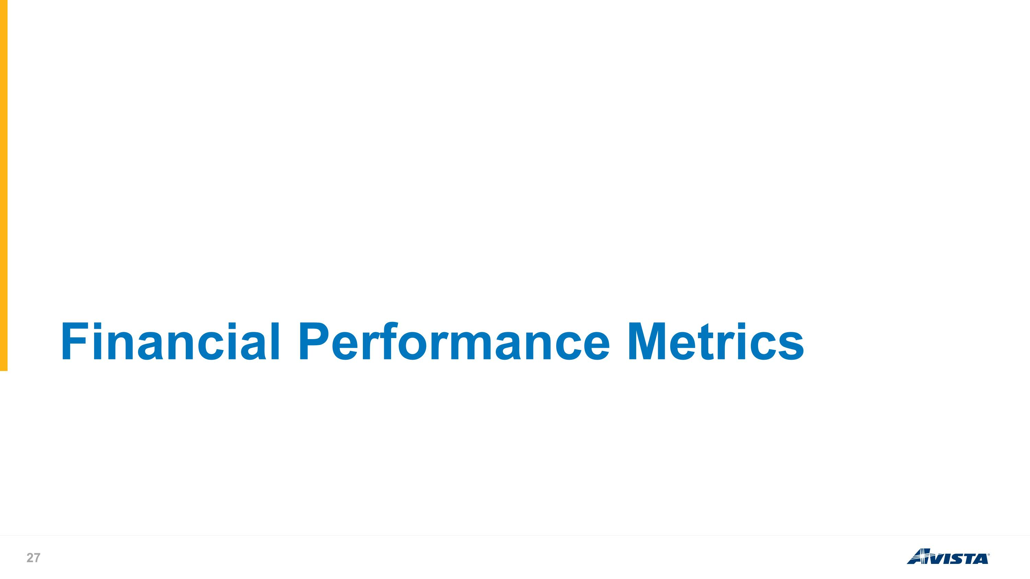
Financial Performance Metrics

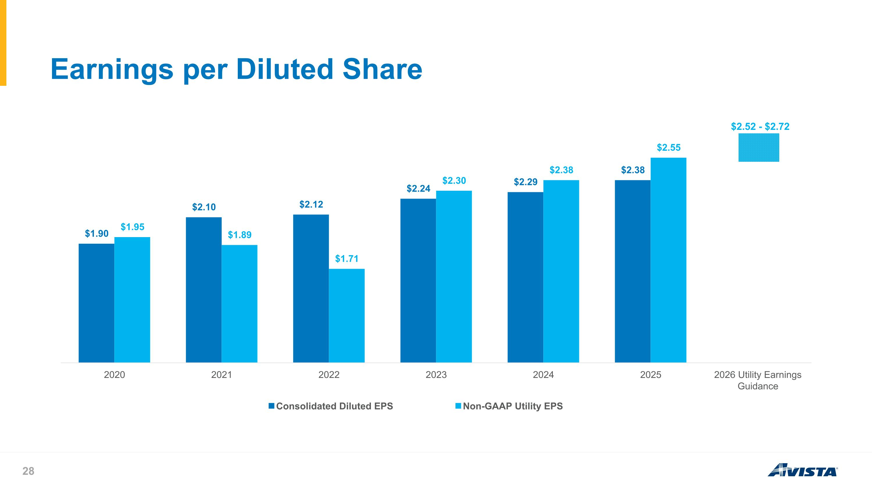
Earnings per Diluted Share $2.52 - $2.72

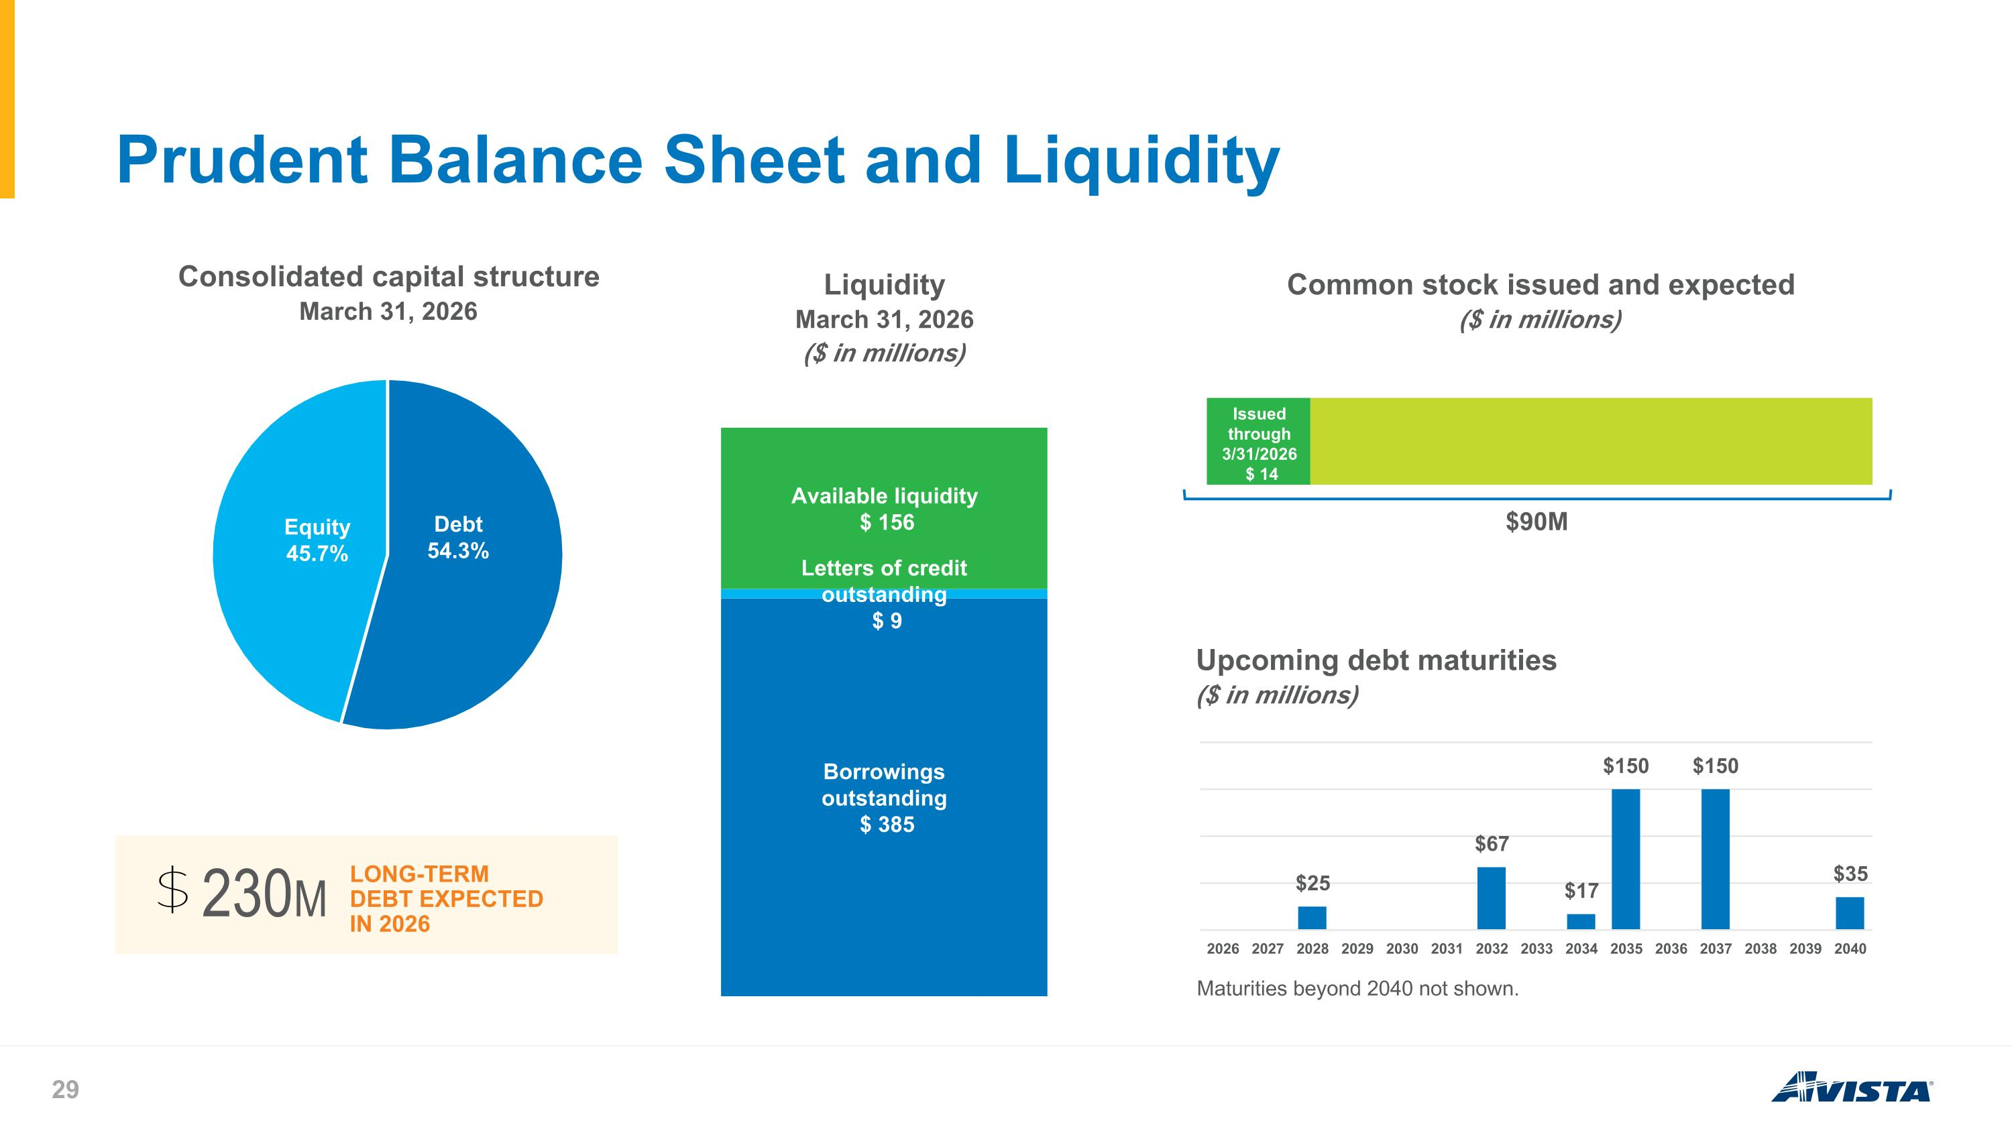
Prudent Balance Sheet and Liquidity Maturities beyond 2040 not shown. LONG-TERM DEBT EXPECTED IN 2026 230M $90M

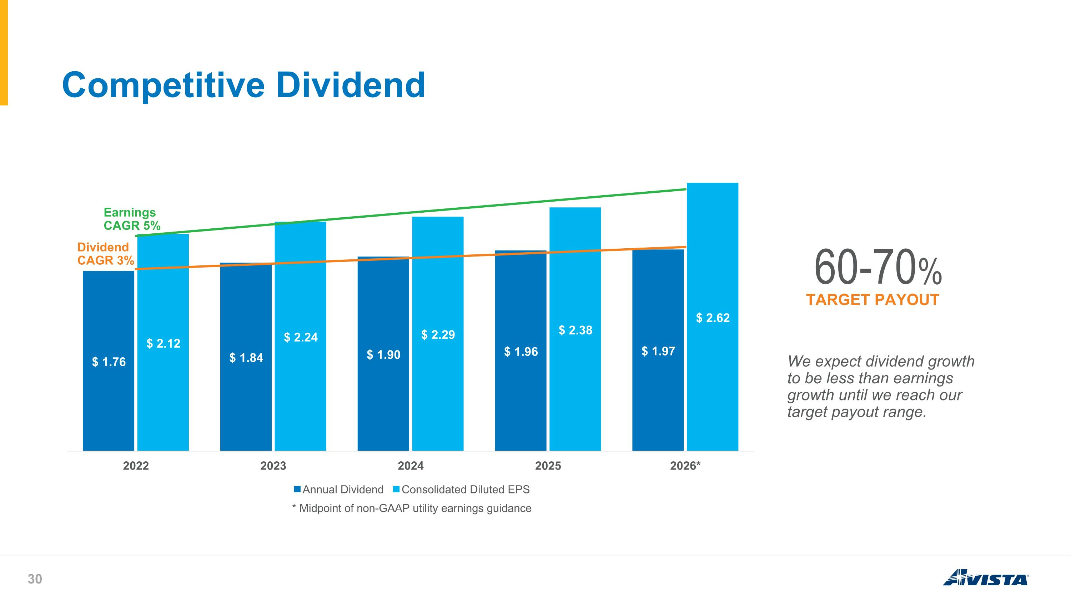
Competitive Dividend * Midpoint of non-GAAP utility earnings guidance TARGET PAYOUT 60-70% We expect dividend growth to be less than earnings growth until we reach our target payout range. Earnings CAGR 5% Dividend CAGR 3%

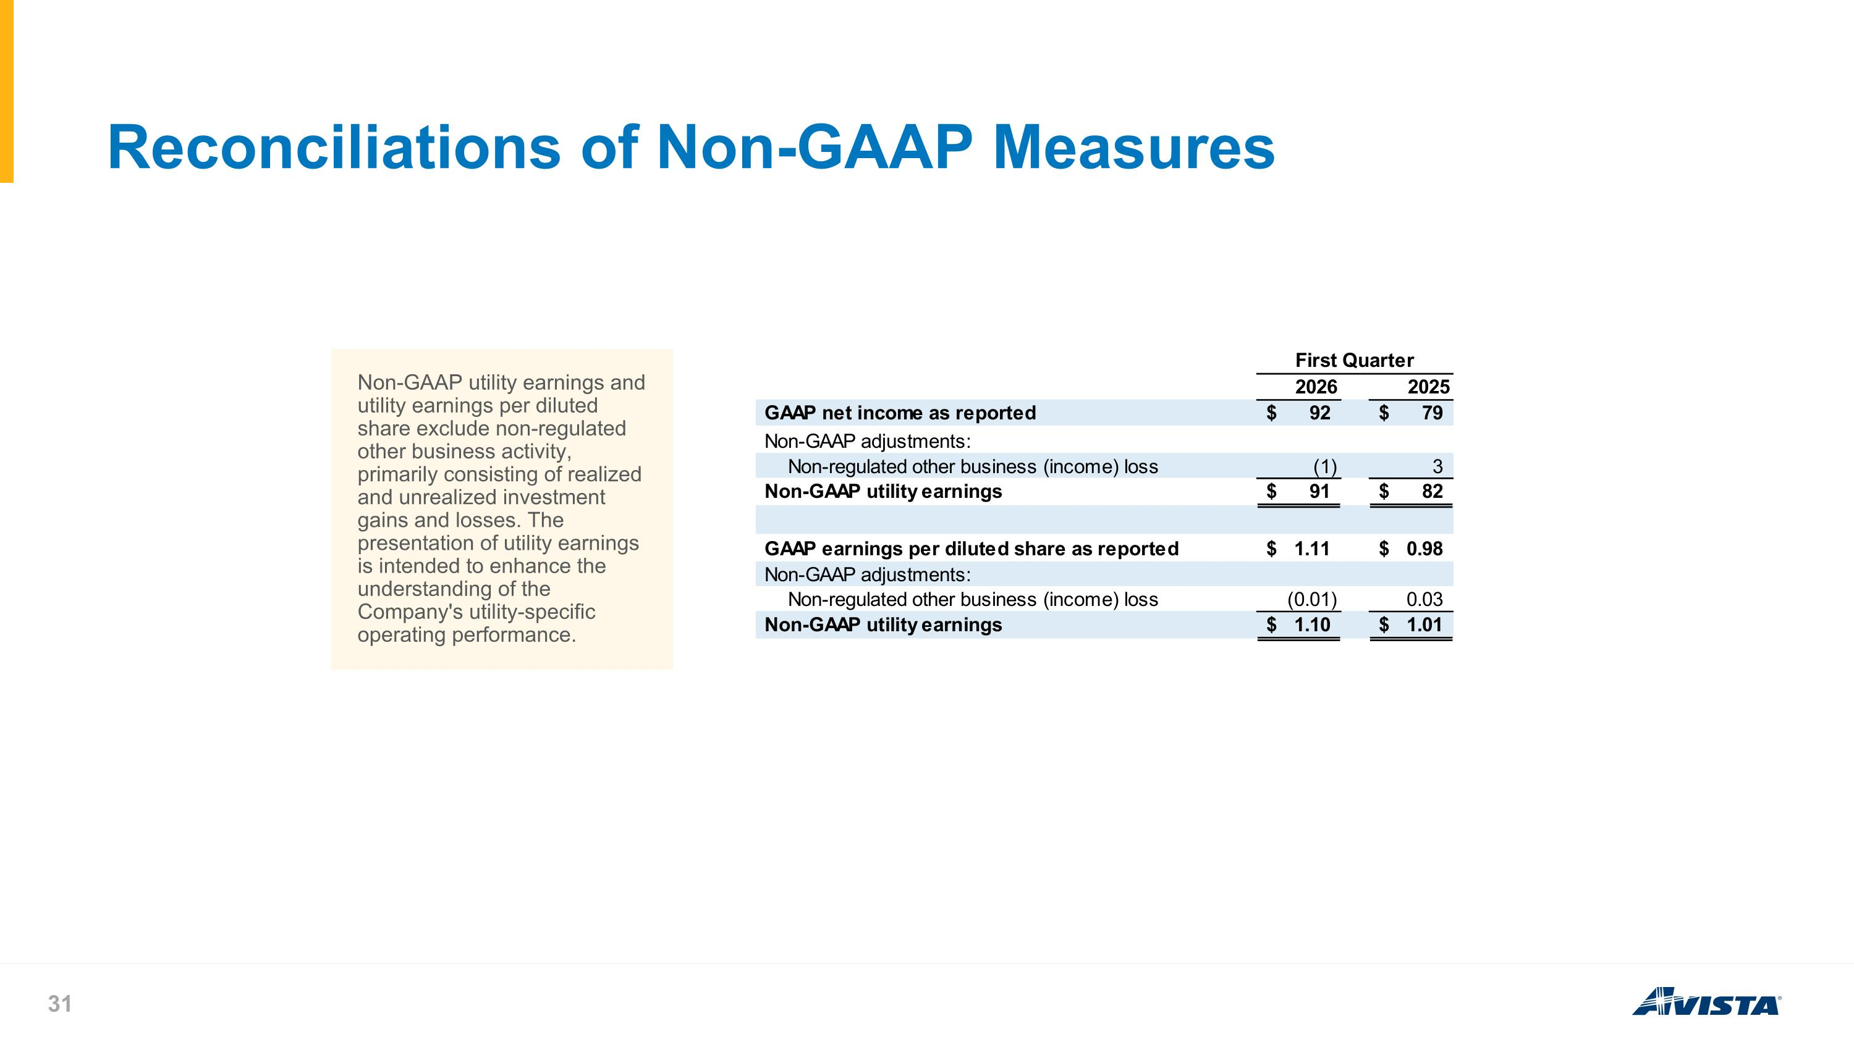
Reconciliations of Non-GAAP Measures Non-GAAP utility earnings and utility earnings per diluted share exclude non-regulated other business activity, primarily consisting of realized and unrealized investment gains and losses. The presentation of utility earnings is intended to enhance the understanding of the Company's utility-specific operating performance.

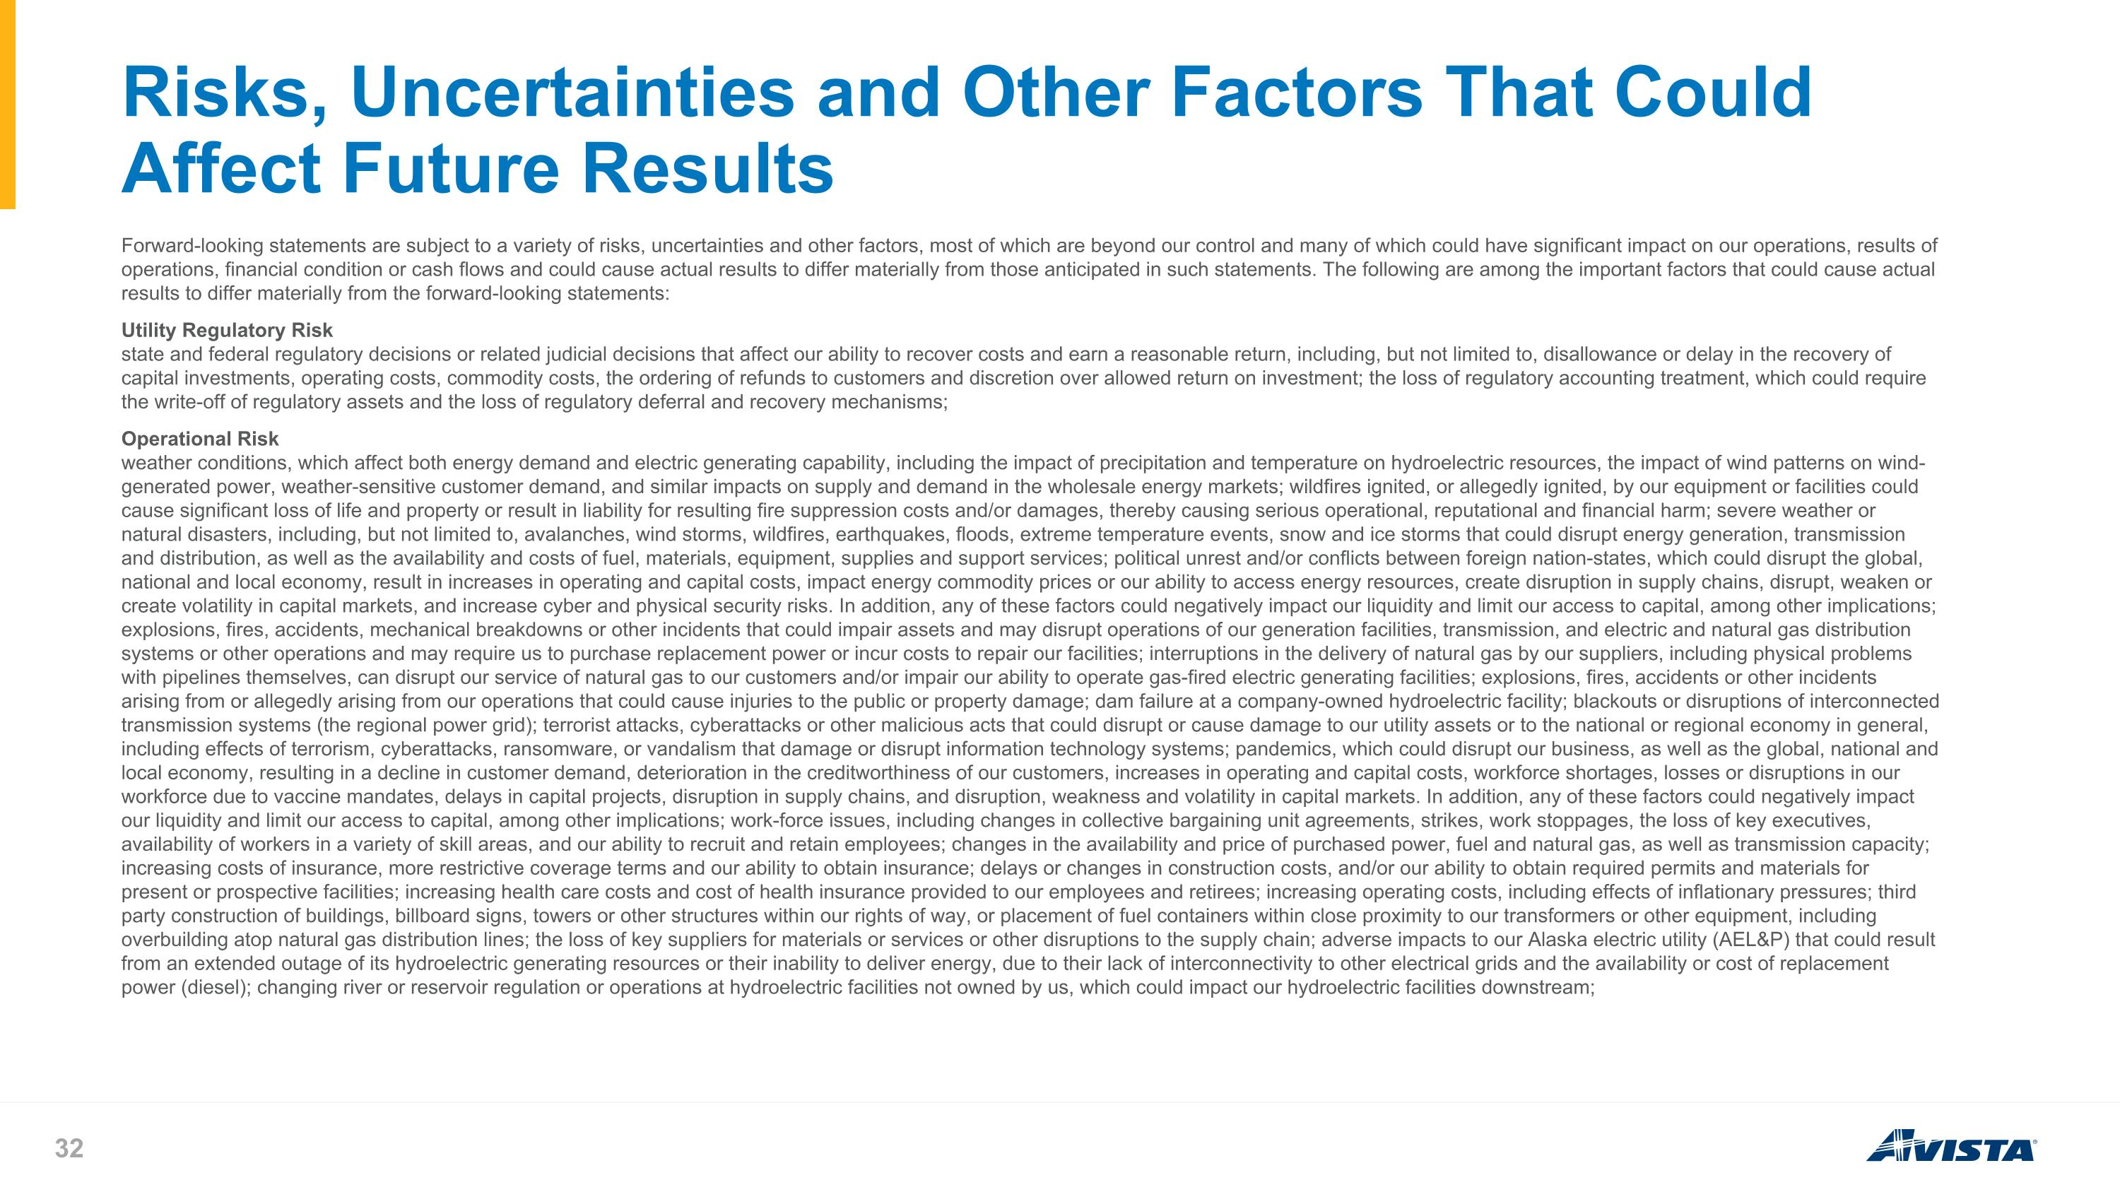
Risks, Uncertainties and Other Factors That Could Affect Future Results Forward-looking statements are subject to a variety of risks, uncertainties and other factors, most of which are beyond our control and many of which could have significant impact on our operations, results of operations, financial condition or cash flows and could cause actual results to differ materially from those anticipated in such statements. The following are among the important factors that could cause actual results to differ materially from the forward-looking statements: Utility Regulatory Risk state and federal regulatory decisions or related judicial decisions that affect our ability to recover costs and earn a reasonable return, including, but not limited to, disallowance or delay in the recovery of capital investments, operating costs, commodity costs, the ordering of refunds to customers and discretion over allowed return on investment; the loss of regulatory accounting treatment, which could require the write-off of regulatory assets and the loss of regulatory deferral and recovery mechanisms; Operational Risk weather conditions, which affect both energy demand and electric generating capability, including the impact of precipitation and temperature on hydroelectric resources, the impact of wind patterns on wind-generated power, weather-sensitive customer demand, and similar impacts on supply and demand in the wholesale energy markets; wildfires ignited, or allegedly ignited, by our equipment or facilities could cause significant loss of life and property or result in liability for resulting fire suppression costs and/or damages, thereby causing serious operational, reputational and financial harm; severe weather or natural disasters, including, but not limited to, avalanches, wind storms, wildfires, earthquakes, floods, extreme temperature events, snow and ice storms that could disrupt energy generation, transmission and distribution, as well as the availability and costs of fuel, materials, equipment, supplies and support services; political unrest and/or conflicts between foreign nation-states, which could disrupt the global, national and local economy, result in increases in operating and capital costs, impact energy commodity prices or our ability to access energy resources, create disruption in supply chains, disrupt, weaken or create volatility in capital markets, and increase cyber and physical security risks. In addition, any of these factors could negatively impact our liquidity and limit our access to capital, among other implications; explosions, fires, accidents, mechanical breakdowns or other incidents that could impair assets and may disrupt operations of our generation facilities, transmission, and electric and natural gas distribution systems or other operations and may require us to purchase replacement power or incur costs to repair our facilities; interruptions in the delivery of natural gas by our suppliers, including physical problems with pipelines themselves, can disrupt our service of natural gas to our customers and/or impair our ability to operate gas-fired electric generating facilities; explosions, fires, accidents or other incidents arising from or allegedly arising from our operations that could cause injuries to the public or property damage; dam failure at a company-owned hydroelectric facility; blackouts or disruptions of interconnected transmission systems (the regional power grid); terrorist attacks, cyberattacks or other malicious acts that could disrupt or cause damage to our utility assets or to the national or regional economy in general, including effects of terrorism, cyberattacks, ransomware, or vandalism that damage or disrupt information technology systems; pandemics, which could disrupt our business, as well as the global, national and local economy, resulting in a decline in customer demand, deterioration in the creditworthiness of our customers, increases in operating and capital costs, workforce shortages, losses or disruptions in our workforce due to vaccine mandates, delays in capital projects, disruption in supply chains, and disruption, weakness and volatility in capital markets. In addition, any of these factors could negatively impact our liquidity and limit our access to capital, among other implications; work-force issues, including changes in collective bargaining unit agreements, strikes, work stoppages, the loss of key executives, availability of workers in a variety of skill areas, and our ability to recruit and retain employees; changes in the availability and price of purchased power, fuel and natural gas, as well as transmission capacity; increasing costs of insurance, more restrictive coverage terms and our ability to obtain insurance; delays or changes in construction costs, and/or our ability to obtain required permits and materials for present or prospective facilities; increasing health care costs and cost of health insurance provided to our employees and retirees; increasing operating costs, including effects of inflationary pressures; third party construction of buildings, billboard signs, towers or other structures within our rights of way, or placement of fuel containers within close proximity to our transformers or other equipment, including overbuilding atop natural gas distribution lines; the loss of key suppliers for materials or services or other disruptions to the supply chain; adverse impacts to our Alaska electric utility (AEL&P) that could result from an extended outage of its hydroelectric generating resources or their inability to deliver energy, due to their lack of interconnectivity to other electrical grids and the availability or cost of replacement power (diesel); changing river or reservoir regulation or operations at hydroelectric facilities not owned by us, which could impact our hydroelectric facilities downstream;

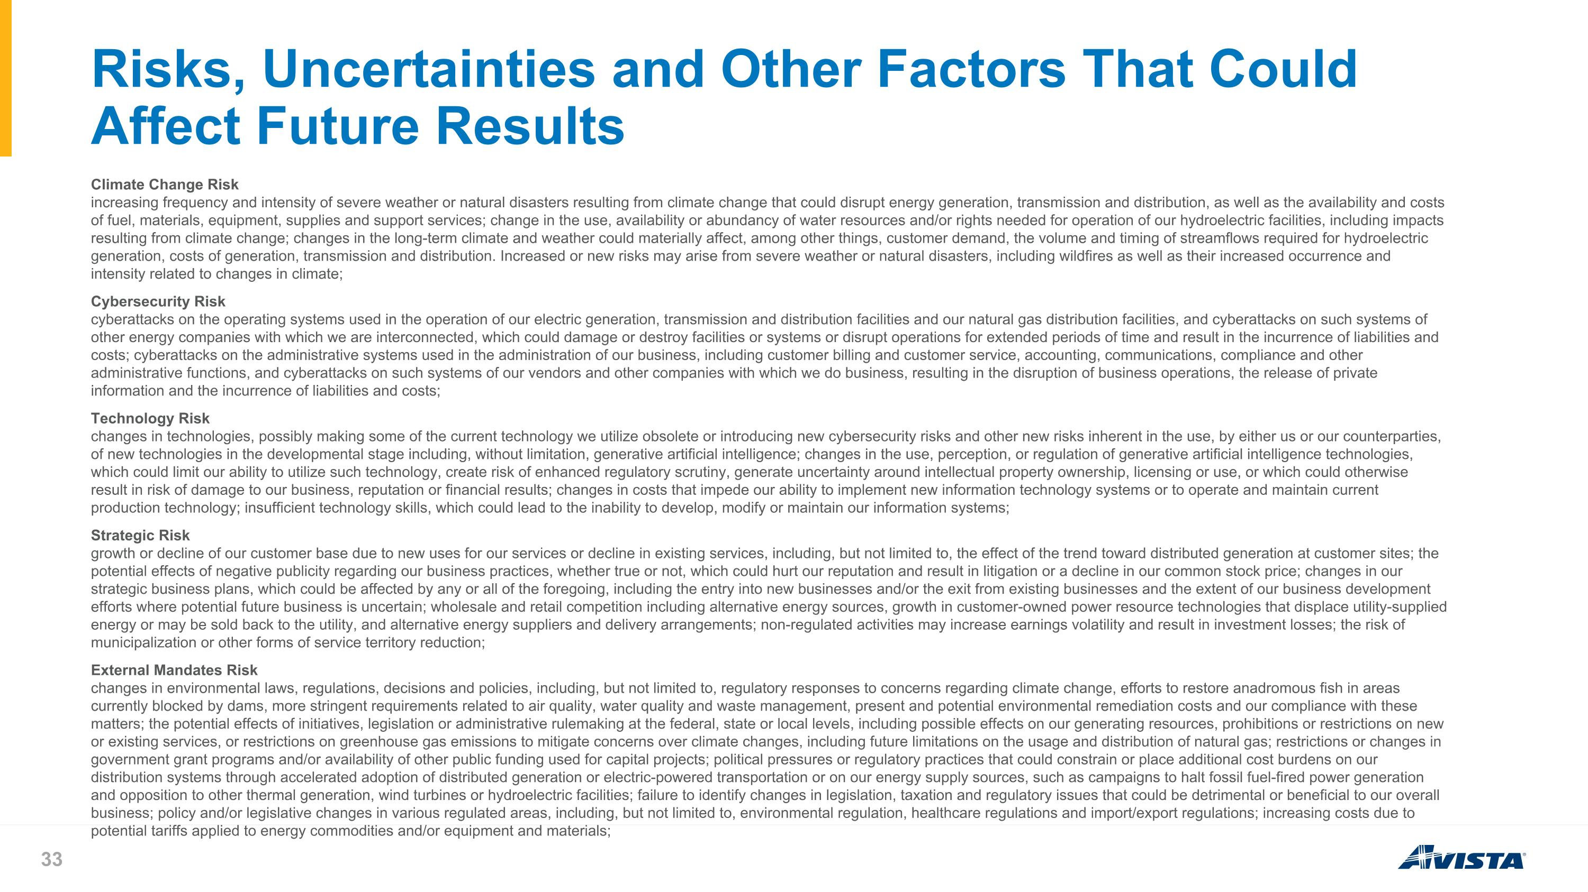
Risks, Uncertainties and Other Factors That Could Affect Future Results Climate Change Risk increasing frequency and intensity of severe weather or natural disasters resulting from climate change that could disrupt energy generation, transmission and distribution, as well as the availability and costs of fuel, materials, equipment, supplies and support services; change in the use, availability or abundancy of water resources and/or rights needed for operation of our hydroelectric facilities, including impacts resulting from climate change; changes in the long-term climate and weather could materially affect, among other things, customer demand, the volume and timing of streamflows required for hydroelectric generation, costs of generation, transmission and distribution. Increased or new risks may arise from severe weather or natural disasters, including wildfires as well as their increased occurrence and intensity related to changes in climate; Cybersecurity Risk cyberattacks on the operating systems used in the operation of our electric generation, transmission and distribution facilities and our natural gas distribution facilities, and cyberattacks on such systems of other energy companies with which we are interconnected, which could damage or destroy facilities or systems or disrupt operations for extended periods of time and result in the incurrence of liabilities and costs; cyberattacks on the administrative systems used in the administration of our business, including customer billing and customer service, accounting, communications, compliance and other administrative functions, and cyberattacks on such systems of our vendors and other companies with which we do business, resulting in the disruption of business operations, the release of private information and the incurrence of liabilities and costs; Technology Risk changes in technologies, possibly making some of the current technology we utilize obsolete or introducing new cybersecurity risks and other new risks inherent in the use, by either us or our counterparties, of new technologies in the developmental stage including, without limitation, generative artificial intelligence; changes in the use, perception, or regulation of generative artificial intelligence technologies, which could limit our ability to utilize such technology, create risk of enhanced regulatory scrutiny, generate uncertainty around intellectual property ownership, licensing or use, or which could otherwise result in risk of damage to our business, reputation or financial results; changes in costs that impede our ability to implement new information technology systems or to operate and maintain current production technology; insufficient technology skills, which could lead to the inability to develop, modify or maintain our information systems; Strategic Risk growth or decline of our customer base due to new uses for our services or decline in existing services, including, but not limited to, the effect of the trend toward distributed generation at customer sites; the potential effects of negative publicity regarding our business practices, whether true or not, which could hurt our reputation and result in litigation or a decline in our common stock price; changes in our strategic business plans, which could be affected by any or all of the foregoing, including the entry into new businesses and/or the exit from existing businesses and the extent of our business development efforts where potential future business is uncertain; wholesale and retail competition including alternative energy sources, growth in customer-owned power resource technologies that displace utility-supplied energy or may be sold back to the utility, and alternative energy suppliers and delivery arrangements; non-regulated activities may increase earnings volatility and result in investment losses; the risk of municipalization or other forms of service territory reduction; External Mandates Risk changes in environmental laws, regulations, decisions and policies, including, but not limited to, regulatory responses to concerns regarding climate change, efforts to restore anadromous fish in areas currently blocked by dams, more stringent requirements related to air quality, water quality and waste management, present and potential environmental remediation costs and our compliance with these matters; the potential effects of initiatives, legislation or administrative rulemaking at the federal, state or local levels, including possible effects on our generating resources, prohibitions or restrictions on new or existing services, or restrictions on greenhouse gas emissions to mitigate concerns over climate changes, including future limitations on the usage and distribution of natural gas; restrictions or changes in government grant programs and/or availability of other public funding used for capital projects; political pressures or regulatory practices that could constrain or place additional cost burdens on our distribution systems through accelerated adoption of distributed generation or electric-powered transportation or on our energy supply sources, such as campaigns to halt fossil fuel-fired power generation and opposition to other thermal generation, wind turbines or hydroelectric facilities; failure to identify changes in legislation, taxation and regulatory issues that could be detrimental or beneficial to our overall business; policy and/or legislative changes in various regulated areas, including, but not limited to, environmental regulation, healthcare regulations and import/export regulations; increasing costs due to potential tariffs applied to energy commodities and/or equipment and materials;

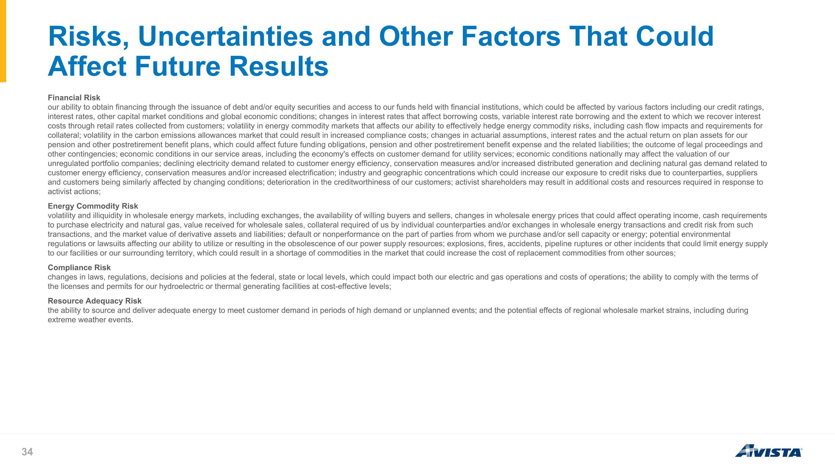
Risks, Uncertainties and Other Factors That Could Affect Future Results Financial Risk our ability to obtain financing through the issuance of debt and/or equity securities and access to our funds held with financial institutions, which could be affected by various factors including our credit ratings, interest rates, other capital market conditions and global economic conditions; changes in interest rates that affect borrowing costs, variable interest rate borrowing and the extent to which we recover interest costs through retail rates collected from customers; volatility in energy commodity markets that affects our ability to effectively hedge energy commodity risks, including cash flow impacts and requirements for collateral; volatility in the carbon emissions allowances market that could result in increased compliance costs; changes in actuarial assumptions, interest rates and the actual return on plan assets for our pension and other postretirement benefit plans, which could affect future funding obligations, pension and other postretirement benefit expense and the related liabilities; the outcome of legal proceedings and other contingencies; economic conditions in our service areas, including the economy's effects on customer demand for utility services; economic conditions nationally may affect the valuation of our unregulated portfolio companies; declining electricity demand related to customer energy efficiency, conservation measures and/or increased distributed generation and declining natural gas demand related to customer energy efficiency, conservation measures and/or increased electrification; industry and geographic concentrations which could increase our exposure to credit risks due to counterparties, suppliers and customers being similarly affected by changing conditions; deterioration in the creditworthiness of our customers; activist shareholders may result in additional costs and resources required in response to activist actions; Energy Commodity Risk volatility and illiquidity in wholesale energy markets, including exchanges, the availability of willing buyers and sellers, changes in wholesale energy prices that could affect operating income, cash requirements to purchase electricity and natural gas, value received for wholesale sales, collateral required of us by individual counterparties and/or exchanges in wholesale energy transactions and credit risk from such transactions, and the market value of derivative assets and liabilities; default or nonperformance on the part of parties from whom we purchase and/or sell capacity or energy; potential environmental regulations or lawsuits affecting our ability to utilize or resulting in the obsolescence of our power supply resources; explosions, fires, accidents, pipeline ruptures or other incidents that could limit energy supply to our facilities or our surrounding territory, which could result in a shortage of commodities in the market that could increase the cost of replacement commodities from other sources; Compliance Risk changes in laws, regulations, decisions and policies at the federal, state or local levels, which could impact both our electric and gas operations and costs of operations; the ability to comply with the terms of the licenses and permits for our hydroelectric or thermal generating facilities at cost-effective levels; Resource Adequacy Risk the ability to source and deliver adequate energy to meet customer demand in periods of high demand or unplanned events; and the potential effects of regional wholesale market strains, including during extreme weather events.

